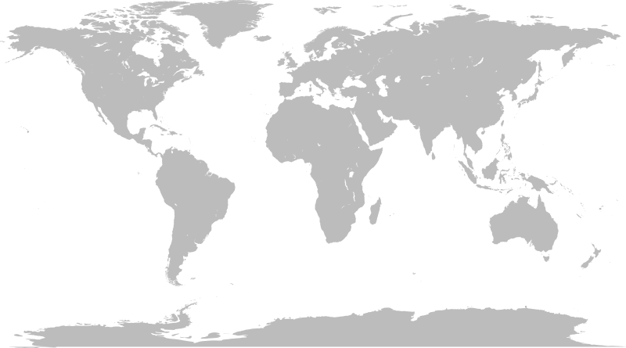

- Label the oceans
- Label the continents
- Draw the Atlantic trade routes
- Show the three zones in the Indian Ocean trade network
- Identify

  - Great Britain
  - India
  - China
  - Egypt
  - the United States
  - Australia
  - Russia
  - Japan
  - Mexico
  - Brazil
  - Spain
  - France
  - Germany
  - Italy
  - Turkey
  - Philippines
  - Mesopotamia
  - Mesoamerica
  - Maori homeland
  - Safavid heartland

