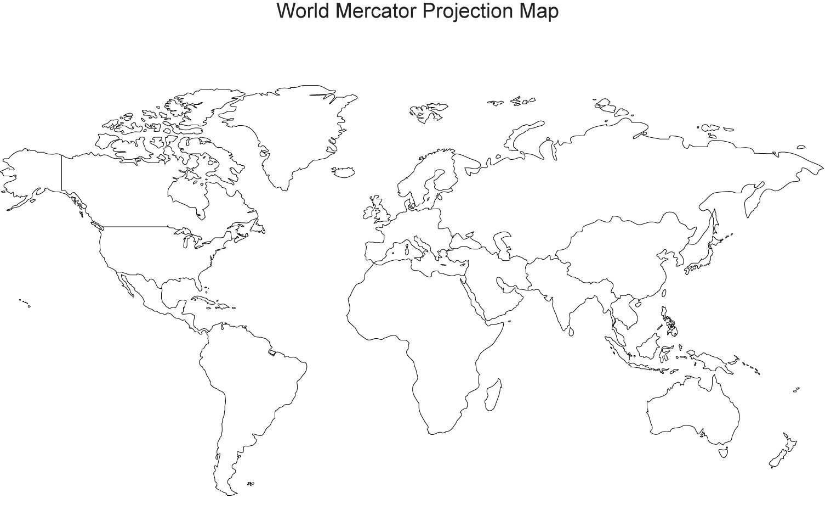
- Shade in and label the Ancient Egyptian RVC. Draw the river that supported the RVC from its source to the sea.
- Shade in and label the Ancient Mesopotamian RVC. Draw the river that supported the RVC from its source to the sea.
- Shade in and label the Indian RVC. Draw the river that supported the RVC from its source to the sea.
- Shade in and label the Chinese RVC. Draw the river that supported the RVC from its source to the sea.
- Label the continents, oceans, and at least FIVE things you already know (c’mon, impress me).

