- Period 1: From Hunting and Gathering to Civ.s: 2.5 Mil BCE1000BCE
  - Changes
    - Neolithic Revolution
      - Settle down b/c sedentary agriculture
      - Dependable foodspecialization
    - Civ.s rose
      - Not everywhere
    - Men and women have no formal inequality
    - Serious wars when soc.s get advanced
    - Hunting gets less productive b/c Ice Age over so no big game
    - Higher birth rates so more workers
  - Continuity
    - Change happened slow
      - Takes a while to make new things
    - Some people liked hunting-gathering
  - Info
    - PaleolithicNeolithicNeolithic Rev. Bronze Age
  - What’s included
    - Stuff before classical civ.s
    - RVCs
      - Mesopotamia, Egypt, Shang, Harappa, Mohenjo Daro
    - Just Valley Civ.s
      - Olmec and Chavin
- Period 2: The Classical Period, 1000BCE600CE: Uniting Large Regions
  - Major development was formation of large regional civ.s
  - Civ.s developed mostly separately
    - But trading b/w was there
  - Triggers for Change
    - Military Conquest b/c of Fe tools and weapons
      - If it’s big, then leaders tied them culturally and commercially
  - The Big Changes
    - Each Classical civ. had own social structure, religion, political system, science system, and art
    - Establishment of cultures that developed and left durable legacies
      - All had vigorous internal trade
    - Each promoted a common cultural system to legitimize customs, integrate elites, and make bonds
    - Each conquered
    - Nomads facilitated trade
    - Confucianism and Greek science
  - Continuities
    - No sweeping technological development
      - Most peasants used traditional agricultural tools
    - No great advances in transportation, other than road systems in powerful gov.s
    - Rural peoples remained apart from classical culture
    - Patriarchy (when in doubt, use this)
    - All retained and built on past soc.s
      - $ already made, so was idea of coded law
  - What’s included
    - Classical civ.s
      - Zhou (Confucianism)(Warring States)QinHan (Era of Division)
      - Mauryan dynasty (Buddhism), Guptas
      - Persian (Cyrus The Great)
      - Sassanids
      - Greece
      - Rome (Republic)(Empire)
      - Axum, Ethiopia
      - Japan(regional states get sophisticated)
      - Olmec, Maya, Inca
      - Birth of Byzantine
    - Birth of major religions (except Islam)
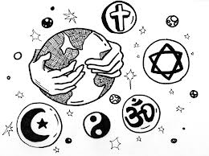
- Period 3: Post-Classical Period, 600CE1450CE: New Faith and New Commerce
  - Major developments were spread of the major world religions: Buddhism, Christianity, Islam(the new faith part)
  - Trade spread religion
    - How religion also spreads: MMMmerchants, missionaries, military
  - Indian Ocean and Mediterranean Sea were important trade routes
  - Triggers for Change
    - Economic decline and increasing decline b/c fall of classical civs
      - People turn to religion for security, reassurance, and guidance
    - Collapse of established boundaries
      - Fall of Rome lets Arabs take over
      - Since Byzantine’s can’t take what they had before b/c Caliphates already beat them to the punch so they go West to Russia and East Europe
    - Expanding trade: better ships and new navigational devices
    - Religion and Commerce
  - Big Changes
    - Spread of religions
    - Islam was dynamic
    - Regular trade
      - Spread technology, like paper; ideas, like math; and disease, like the Black Plague
  - Continuity
    - People revived classical forms
      - China uses Confucianism and the bureaucracy
    - China likes to be continuous
      - Dynastic cycle
    - Slavery
    - Blending traditional forms with missionary religions
      - African Christianity had indigenous parts to it
      - Voodoo
    - No systemic changes in social or political forms
      - Landlords dominant
      - Castes
    - Americas and Oceania kept doing their own thing
  - Women
    - The religions said women were spiritually = to men
    - Trade made gender inequality
    - Footbinding in this period
  - What’s included
    - Islam stuff and its decline
    - Medieval
    - Mongols and fall which leads to a political vacuum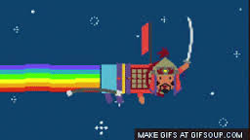
    - Sui, Tang, Song, Yuan(which is Mongol)
    - Brief Chinese experiment in leading world trade, so a bit of the Ming
    - Byzantine culture
    - Tenochtitlan w/ Aztecs
    - Incas
    - Copying
      - Japan, Korea, and sometimes Vietnam from China (Sinification)
      - Russia from the Byzantines
- Period 4: The Early Modern Period, 1450CE1750CE: The World Shrinks
  - Big changes were overseas civ.s and worldwide trade routes
  - Triggers for change
    - Revival of empire building
      - Ottomans conquer Constantinople and expand
      - To grow an empire, need an army and taxes which both France and England did after the 100yrs War
    - Steady progression of explorations by Europeans along the Atlantic coast of Africa
      - To find ways to trade w/ E. Asia w/o having to go through the Islamic middlemen
    - New military technologies
      - Compasses, better sailing shipscaravels
      - GUNS
  - Big Changes
    - A New Global Economy
      - International trade, with Americas for the 1st time
      - Brings the world closer
    - Biological exchange of food, animals, and people
      - Columbian exchange
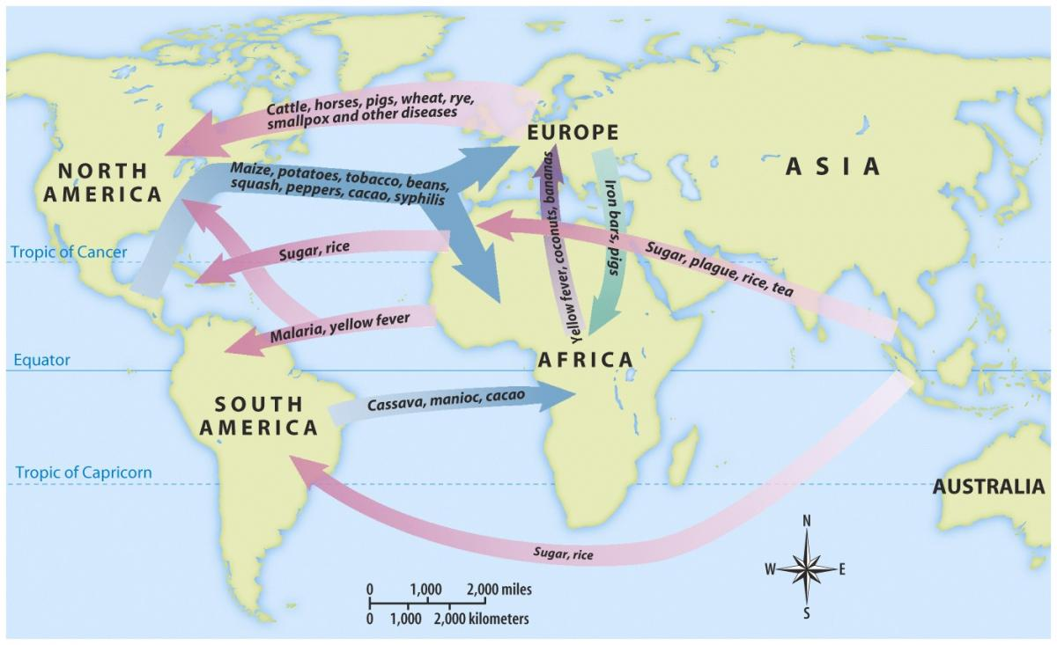
      - New foods=more population
      - Diseases kill natives
        - Which is why slave trade for labor is so important
      - Beasts of burden for Americas
    - New Empires
      - Gunpowder ones
    - West Europe’s position goes up
  - Continuities
    - Patriarchy
    - No sweeping, global cultural change
      - Cultural stability
    - No technological breakthrough until after Industrial Revolution
    - Dominance of traditional agriculture
  - Work
    - Growing pressure to work harder
      - Child labor, really elderly working
  - What’s included you ask? Well,
    - New global trading patterns
    - Russia selectively westernizing and becoming a gunpowder empire
    - Formative period for Latin America
    - New Muslim states in Middle East and SE Asia
      - Mughal, Ottoman, Safavid
- Period 5: The Dawn of the Industrial Age, 1750CE1914CE
  - Big Changes
    - Radically new kind of technology and economy rose in a few parts of the world (fancy way of saying the Industrial Rev. happened)
    - Industrial countries get advantages
      - Power advantage with weapons, economic advantage
  - Triggers for Change
    - Europe had a trading advantage and inventioning
    - Other gunpowder empires were struggling
    - European gov.s began to create conditions designed to encourage industrial growth
      - Improving roads, developing central banks, limiting rights of labor
    - Population boom
  - The Big Changes
    - Industrialization needs new powercoal
      - Steam engine
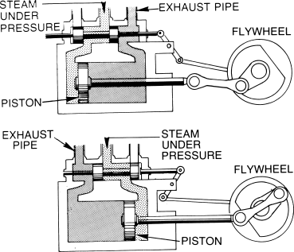
    - Improvements in agricultural production supported growth
    - Rise of factory system
      - Work moved out of the home, challenging traditional family life where all members participated
        - Women stayed in the house

      - Child labor at first, then schooling
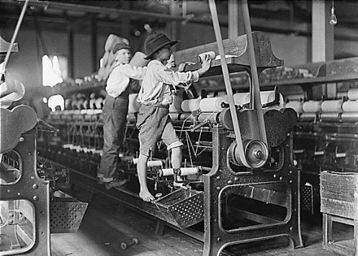
    - Politics
      - Middle class voice
      - Urban workers grow restless so gov.s give them the right to vote
      - New nationalist loyalties
    - For colonies, have to churn out food and cheap raw materials
    - Western dominance w/ imperialism in Africa and Asia (not Latin America)
    - Institution of slavery under attack
      - New ideas of human rights
      - As it ended, harsh, low paid labor increased
    - Pollution
    - Introduction of cotton and coffee to new parts in Africa and Latin America caused soil erosion
  - Continuities
    - Industrialization happened over decades
    - When Russia’s literacy goes high, adventure stories show triumph of state over disorder
      - Contrast to West
    - Invention of traditions
      - Thanksgiving, family as a haven
  - Leisure
    - In early decades, declined b/c long work like when agriculture replaced hunter-gatherers
    - Laterpro sports that spread around
  - What’s included
    - Industrial rev. and new politics
    - New settler soc.s in U.S, Canada, New Zealand, Australia
    - World economy and Western imperialism
    - Asian response to challenges of Western power and economic change
      - Boxer rebellion, self-strengthening movement
    - Russia’s and Japan’s industrialization and westernization
- Period 6: The 20th century: 1914CEToday CE (according to the book, it’s 2006 still)
  - Changes
      - Great Western empire, Ottoman, Austria-Hungary, and part of the Russian empire implode by end of century
      - More new nations, yay
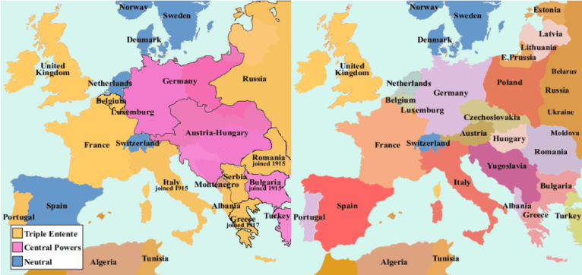
      - New political forms
        - USED to be monarchy or empire
  - Triggers for Change #1
    - European dominance crashes and decolonization
      - WWI, Depression, WWII
      - Anticolonial nationalisms
  - What Changes #1
    - US and USSR become world superpowers, until USSR dies
    - New methods of transportation and communication
    - Warkill more people faster
  - Triggers for Change #2
    - Massive technology innovation
  - What Changes #2
    - Facilitates population growth
  - Trigger for Change #3
    - Demographic explosion
  - The Big Changes
    - Political innovations due to rev.s and decolonization
      - Ex. Totalitarian (communist or fascist)
    - More complex world economy
    - Cultural forces encouraged new secular loyalties
      - Nationalism, Marxism, Consumerism(don’t know how you can be loyal to that…), Science
    - Big strides for women
    - New round of globalization in 1960s+
      - Receded in the beginning of the century w/ key countries like Russia, Germany, Japan, U.S., and China pulling out
    - Globalization changed the environment
    - Efforts to destroy social inequality involved attempts to reverse emotional passivity
      - Childrearing manual in U.S. by civil rights leaders to show African Americans to instill assertiveness in their kids
  - What stayed the same (Continuities)
    - While a number of regions advanced industrialization, others remained focused on production of low-cost stuff like raw materials and food
      - Africa, Latin America, SE Asia
    - Resistance to change
      - Fundamentalist religions and groups
      - Don’t want to change gender relations
    - Older traditions
      - That’s why McDonalds has to sell veggie burgers in India
    - Many soc.s retained larger orientations derived from their traditions
      - U.S. wants to keep sovereignty, so rejects many treaties
      - China’s repression of the Falun Gong Buddhist movement is like the repression of Buddhism in the Tang
      - Russia returns to authoritarianism in early 21st century
  - What’s included
    - WWI, the great depression, WWII
    - Communism, fascism
    - Birth of Israel because Zionism
    - Freeing of India and making of Pakistan
    - Cold War
    - Globalization
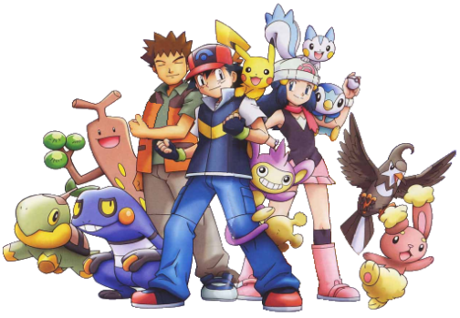
    - Some more stuff but I don’t have my book on me

