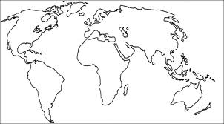
The Muslim Empires Map

- Create a legend in the bottom right corner of this sheet.
- Name the legend: “The Muslim Empires, late 17th Century”
- Add to your legend The Ottoman Empire, and assign a color.
- Add to your legend The Safavid Empire, and assign a color.
- Add to your legend The Mughal Empire, and assign a color.
- Color the map accordingly!
- Add anything else that will give context to the time and place.

