AP World Must-Know Terms Kellogg 2014
In order to reference geography throughout the year, it is important that everyone has an understanding of major regions and geographical features. This guide is to be used as the beginning of your knowledge of geography for this class, not the end of your knowledge of geography in this class! You may be tested on this throughout the year!
Official AP Continents
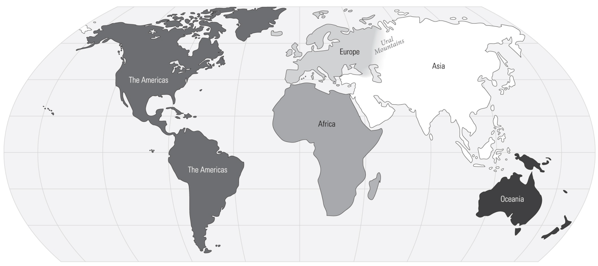

Most Misunderstood Regions, Clarified by AP
This map is NOT the only regions you must know in order to succeed on the AP test. This is only to clarify commonly mistaken regions (for example, many students confuse South Asia and Southeast Asia).
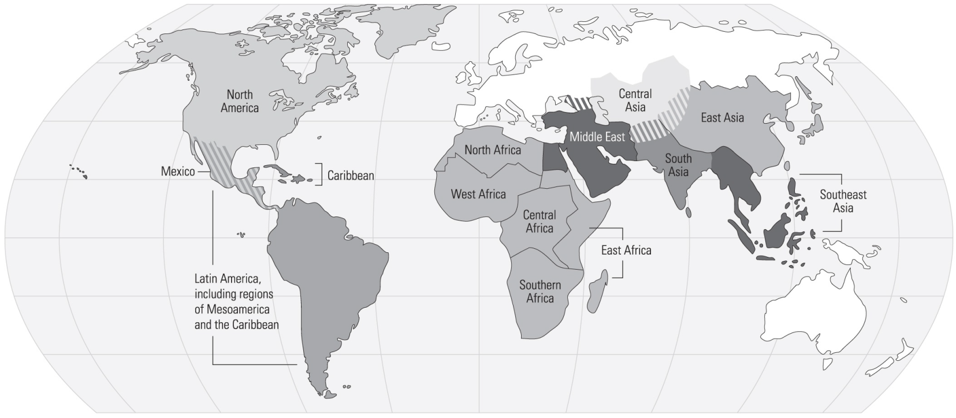

AP World Geography Must-Know Terms Kellogg 2014
Major Geographical Features to Know
You may use colored pencils, markers, highlighters to mark these places on the map below.
Oceans (and their surroundings) |  | Seas/Gulfs (and their surroundings) |  |  | Rivers (and their surroundings)
Pacific ⃝  Atlantic ⃝  Indian ⃝  Arctic ⃝ |  | Mediterranean Sea ⃝  Persian Gulf ⃝  Red Sea ⃝  Black Sea ⃝  Caribbean Sea ⃝ |  | Gulf of Mexico ⃝  Arabian Sea ⃝  Bay of Bengal ⃝  South China Sea ⃝ | Tigris/Euphrates ⃝  Indus ⃝  Ganges ⃝  Huang He (Yellow River) ⃝  Yangzi (Chiang Jiang) ⃝  Nile ⃝  Congo ⃝  Niger ⃝  Mississippi ⃝  Missouri ⃝  Amazon ⃝
Mountain Ranges/Plateaus |  |  | Plains/Steppes |  | Deserts
Himalayas ⃝  Tibetan Plateau ⃝  Deccan Plateau ⃝  Caucuses ⃝  Rockies ⃝ | Appalachians ⃝  Andes ⃝  Urals ⃝  Tian Shan ⃝ |  | Great Plains ⃝  Russian Steppe ⃝  Kazakh Steppe ⃝  Mongolian Steppe ⃝ |  | Sahara ⃝  Kalahari ⃝  Taklamakan ⃝  Gobi ⃝  Arabian ⃝  Great Australian Desert ⃝

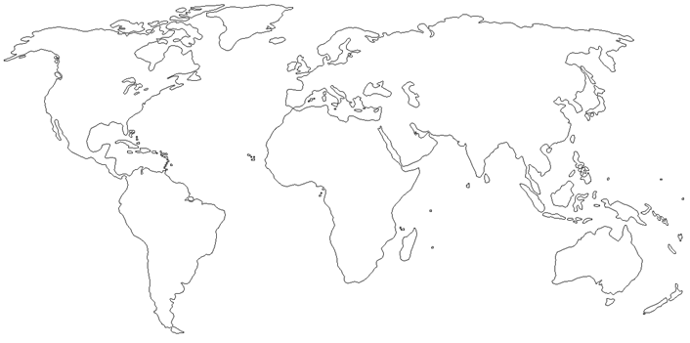

Social | Meaning:
Class structures
Gender relations
Social Mobility
Social Barriers
Urbanization
Tolerance
Freedoms/Rights
Political | Meaning:
Government
Leadership
Bureaucracy
Legitimization
Conflict (war)
Military/Militarism
Legal/Court Systems
Interaction w/Environment | Meaning:
Geography
Barriers/Highways
Climate/Weather Patterns
Flora and Fauna
Natural resources
Disease
Cultural | Meaning:
Religion
Language
Art/Architecture
Writing
Clothing
Education
Nationalism
Economic | Meaning:
Material Wealth
Production (creation)
Distribution (trade)
Consumption (use)
Mobilization of Labor
Wealth distribution
Banking/Currency

Political | Meaning:
- Political Structures
- Forms of Government
- Leaders
- Nationalism, Nations
- Revolts, Revolutions
- War/Diplomacy
Interaction w/Environment | Meaning:
- Demography, Settlement
- Urbanization, Cities
- Migration, movement
- Geography, Terrain
- Land Management Systems
- Regions
Religions/Belief Systems | Meaning:
- Religion
- Belief Systems
- Philosophies/Ideologies
Arts and sciences | Meaning:
- Art, Music, Writing, Lit.
- Intellectual
- Math & Science, Education
Technology | Meaning:
- Tools
- Writing
- Innovations & Inventions
- Industrialization
Economy | Meaning:
- Agricultural, pastoral, prod.
- Economic & Labor Systems
- Industrialization
- Capitalism, Socialism
- Trade and Commerce
- Globalization
- How do people make $$$?
Social | Meaning:
- Gender Roles, Relations
- Family, Kinship
- Racial, Ethnic Constructions
- Social, Economic Classes
- Lifestyles
- Elites, inequalities

