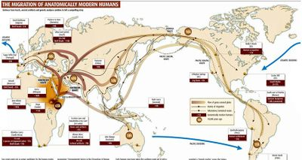
Era 1: Technological & Environmental Transformations, to c. 600 B.C.E.

Key Concept 1.1: Big Geography and the Peopling of the Earth
The term Big Geography draws attention to the global nature of world history. Throughout the Paleolithic period, humans migrated from Africa to Eurasia, Australia, and the Americas. Early humans were mobile and creative in adapting to different geographical settings from savanna to desert to Ice Age tundra. By making an analogy with modern hunter-forager societies, anthropologists infer that these bands were relatively egalitarian. Humans also developed varied and sophisticated technologies.

- Archeological evidence indicates that during the Paleolithic era, hunting-foraging bands of humans gradually migrated from their origin in East Africa to Eurasia, Australia, and the Americas, adapting their technology and cultures to new climate regions.
  - Humans used fire in new ways: to aid hunting and foraging, to protect against predators, and to adapt to cold environments.
  - Humans developed a wider range of tools specially adapted to different environments from tropics to tundra.
  - Economic structures focused on small kinship groups of hunting-foraging bands that could make what they needed to survive. However, not all groups were self-sufficient; they exchanged people, ideas, and goods.

Key Concept 1.2: The Neolithic Revolution and Early Agricultural Societies
In response to warming climates at the end of the last Ice Age, from about 10,000 years ago, some groups adapted to the environment in new ways, while others remained hunter-foragers. Settled agriculture appeared in several different parts of the world. The switch to agriculture created a more reliable, but not necessarily more diversified, food supply.
Agriculturalists also had a massive impact on the environment through intensive cultivation of selected plants to the exclusion of others, through the construction of irrigation systems, and through the use of domesticated animals for food and for labor. Populations increased; family groups gave way to village life and, later, to urban life with all its complexity. Patriarchy and forced labor systems developed, giving elite men concentrated power over most of the other people in their societies. Pastoralism emerged in parts of Africa and Eurasia. Pastoral peoples domesticated animals and led their herds around grazing ranges. Like agriculturalists, pastoralists tended to be more socially stratified than hunter-foragers. Because pastoralists were mobile, they rarely accumulated large amounts of material possessions, which would have been a hindrance when they changed grazing areas. The pastoralists’ mobility allowed them to become an important conduit for technological change as they interacted with settled populations.

- Beginning about 10,000 years ago, the Neolithic Revolution led to the development of new and more complex economic and social systems.
- Possibly as a response to climatic change, permanent agricultural villages emerged first in the lands of the eastern Mediterranean. Agriculture emerged at different times in Mesopotamia, the Nile River Valley and Sub-Saharan Africa, the Indus River Valley, the Yellow River or Huang He Valley, Papua New Guinea, Mesoamerica, and the Andes.
- Pastoralism developed at various sites in the grasslands of AfroEurasia.
- Different crops or animals were domesticated in the various core regions, depending on available local flora & fauna.
- Agricultural communities had to work cooperatively to clear land and create the water control systems needed for crop production.
- These agricultural practices drastically impacted environmental diversity. Pastoralists also affected the environment by grazing large numbers of animals on fragile grasslands, leading to erosion when overgrazed.

- Agriculture and pastoralism began to transform human societies.
- Pastoralism and agriculture led to more reliable and abundant food supplies, which increased the population.
- Surpluses of food and other goods led to specialization of labor, including new classes of artisans and warriors, and the development of elites.
- Technological innovations led to improvements in agricultural production, trade, and transportation.

Required examples of improvements in agricultural production, trade, and transportation – KNOW ALL:

• Pottery
• Plows
• Woven textiles
• Metallurgy
• Wheels and wheeled vehicles

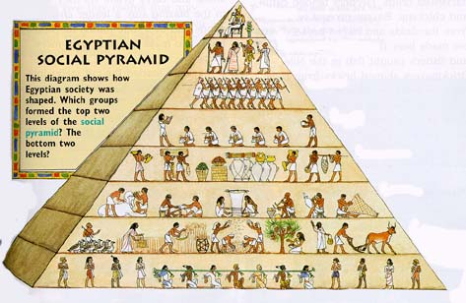
- In both pastoralist and agrarian societies, elite groups accumulated wealth, creating more hierarchical social structures and promoting patriarchal forms of social organization.

Key Concept 1.3: The Development and Interactions of Early Agricultural, Pastoral, and Urban Societies
From about 5,000 years ago, urban societies developed, laying the foundations for the first civilizations. The term civilization is normally used to designate large societies with cities and powerful states. While there were many differences between civilizations, they also shared important features. They all produced agricultural surpluses that permitted significant specialization of labor. All civilizations contained cities and generated complex institutions, such as political bureaucracies, armies, and religious hierarchies. They also featured clearly stratified social hierarchies and organized long-distance trading relationships. Economic exchanges intensified within and between civilizations, as well as with nomadic pastoralists.
As populations grew, competition for surplus resources, especially food, led to greater social stratification, specialization of labor, increased trade, more complex systems of government and religion, and the development of record keeping. As civilizations expanded, they had to balance their need for more resources with environmental constraints such as the danger of undermining soil fertility. Finally, the accumulation of wealth in settled communities spurred warfare between communities and/or with pastoralists; this violence drove the development of new technologies of war and urban defense.

- Core and foundational civilizations developed in a variety of geographical and environmental settings where agriculture flourished.

Required examples of core and foundational civilizations – KNOW ALL + locations:
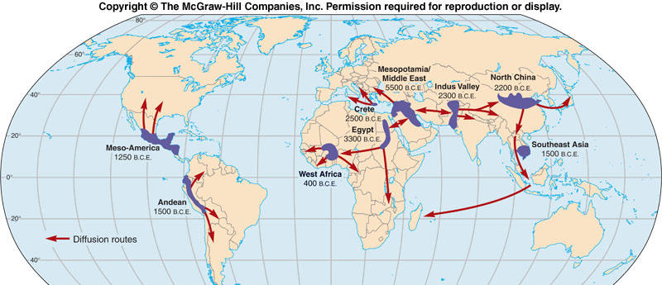
• Mesopotamia in the Tigris and Euphrates River Valleys
• Egypt in the Nile River Valley
• Mohenjo-Daro and Harappa in the Indus River Valley
• Shang in the Yellow River or Huang He Valley
• Olmecs in Mesoamerica
• Chavín in Andean South America

- The first states emerged within core civilizations.
- States were powerful new systems of rule that mobilized surplus labor and resources over large areas. Early states were often led by a ruler whose source of power was believed to be divine or had divine support and/or who was supported by the military.
- As states grew and competed for land and resources, the more favorably situated — including the Hittites, who had access to iron — had greater access to resources, produced more surplus food, and experienced growing populations. These states were able to undertake territorial expansion and conquer surrounding states.
- Early regions of state expansion or empire building were Mesopotamia, Babylonia, and the Nile Valley.
- Pastoralists were often the developers and disseminators of new weapons and modes of transportation that transformed warfare in agrarian civilizations.

- Culture played a significant role in unifying states through laws, language, literature, religion, myths, and monumental art.
- Early civilizations developed monumental architecture and urban planning.
- Elites, both political and religious, promoted arts and artisanship
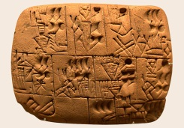
- Systems of record keeping arose independently in all early civilizations and subsequently were diffused.

EXAMPLE OF SYSTEMS OF RECORD KEEPING – KNOW THREE:

• Cuneiform
• Hieroglyphs
• Pictographs
• Alphabets
• Quipu

- States developed legal codes, including the Code of Hammurabi, which reflected existing hierarchies and facilitated the rule of governments over people.
- New religious beliefs developed in this period continued to have strong influences in later periods.

Required examples of new religious beliefs – KNOW ALL:
• The Vedic religion • Hebrew monotheism • Zoroastrianism

- Trade expanded throughout this period from local to regional and transregional, with civilizations exchanging goods, cultural ideas, and technology.

Required examples of trade expansion from local to regional and transregional – KNOW ALL:
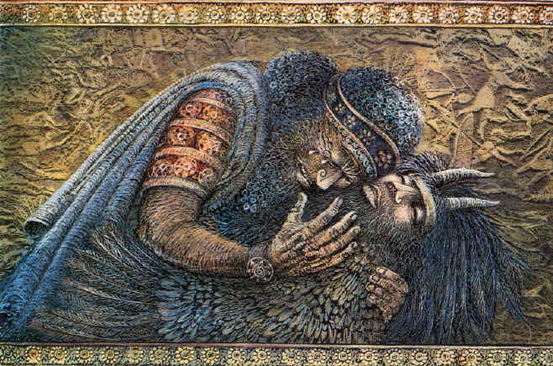
• Between Egypt and Nubia • Between Mesopotamia and the Indus Valley

- Social and gender hierarchies intensified as states expanded and cities multiplied.
- Literature was also a reflection of culture.

EXAMPLE OF LITERATURE – KNOW ONE:
• Rig Veda • Book of the Dead • The “Epic of Gilgamesh”
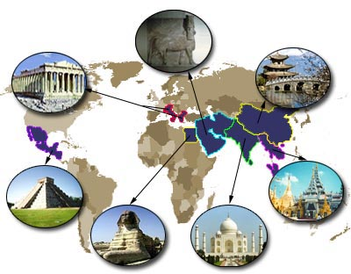
Era 2: Organization & Reorganization of Human Societies,
c. 600 B.C.E. to c. 600 C.E.

Key Concept 2.1: The Development and Codification of Religious and Cultural Traditions
As states and empires increased in size and contacts between regions multiplied, religious and cultural systems were transformed. Religions and belief systems provided a bond among the people and an ethical code to live by. These shared beliefs also influenced and reinforced political, economic, and occupational stratification. Religious and political authority often merged as rulers (some of whom were considered divine) used religion, along with military and legal structures, to justify their rule and ensure its continuation. Religions and belief systems could also generate conflict, partly because beliefs and practices varied greatly within and among societies.

- Codifications and further developments of existing religious traditions provided a bond among the people and an ethical code to live by.
- The association of monotheism with Judaism was further developed with the codification of the Hebrew Scriptures, which also reflected the influence of Mesopotamian cultural and legal traditions. The Assyrian, Babylonian, and Roman empires conquered various Jewish states at different points in time. These conquests contributed to the growth of Jewish Diasporic communities around the Mediterranean and Middle East.
- The core beliefs outlined in the Sanskrit scriptures formed the basis of the Vedic religions — later known as Hinduism — which contributed to the development of the social and political roles of a caste system and in the importance of multiple manifestations of Brahma to promote teachings about reincarnation.

- New belief systems and cultural traditions emerged and spread, often asserting universal truths.
- The core beliefs about desire, suffering, and the search for enlightenment preached by the historic Buddha and recorded by his followers into sutras and other scriptures were, in part, a reaction to the Vedic beliefs and rituals dominant in South Asia. Buddhism changed over time as it spread throughout Asia — first through the support of the Mauryan Emperor Ashoka, and then through the efforts of missionaries and merchants, and the establishment of educational institutions to promote its core teachings.
- Confucianism’s core beliefs and writings originated in the writings and lessons of Confucius and were elaborated by key disciples who sought to promote social harmony by outlining proper rituals and social relationships for all people in China, including the rulers.
- In the major Daoist writings, the core belief of balance between humans and nature assumed that the Chinese political system would be altered indirectly. Daoism also influenced the development of Chinese culture.

EXAMPLE OF THE INFLUENCE OF DAOISM ON THE DEVELOPMENT OF CHINESE CULTURE – KNOW ONE:

• Medical theories and practices
• Poetry
• Metallurgy
• Architecture

- Christianity, based on core beliefs about the teachings and divinity of Jesus of Nazareth as recorded by his disciples, drew on Judaism, and initially rejected Roman and Hellenistic influences. Despite initial Roman imperial hostility, Christianity spread through the efforts of missionaries and merchants through many parts of Afro-Eurasia, and eventually gained Roman imperial support by the time of Emperor Constantine.
- The core ideas in Greco-Roman philosophy and science emphasized logic, empirical observation, and the nature of political power and hierarchy.

- Belief systems affected gender roles. Buddhism and Christianity encouraged monastic life and Confucianism emphasized filial piety

- Other religious and cultural traditions continued parallel to the codified, written belief systems in core civilizations.
- Shamanism and animism continued to shape the lives of people within and outside of core civilizations because of their daily reliance on the natural world.
- Ancestor veneration persisted in many regions.

EXAMPLE OF REGIONS WHERE ANCESTOR VENERATION PERSISTED – KNOW ONE:

• Africa
• The Mediterranean region
• East Asia
• The Andean areas

- Artistic expressions, including literature and drama, architecture, and sculpture, show distinctive cultural developments.
- Literature and drama acquired distinctive forms that influenced artistic developments in neighboring regions and in later time periods.

EXAMPLE OF LITERATURE AND DRAMA – KNOW ONE:
• Greek plays • Indian epics

- Distinctive architectural styles developed in many regions in this period.

EXAMPLE OF REGIONS WHERE DISTINCTIVE ARCHITECTURAL STYLES DEVELOPED – KNOW ONE:

• India
• Greece
• The Roman Empire
• Mesoamerica

- The convergence of Greco-Roman culture and Buddhist beliefs affected the development of unique sculptural developments.

Key Concept 2.2: The Development of States and Empires
As the early states and empires grew in number, size, and population, they frequently competed for resources and came into conflict with one another. In quest of land, wealth, and security, some empires expanded dramatically. In doing so, they built powerful military machines and administrative institutions that were capable of organizing human activities over long distances, and they created new groups of military and political elites to manage their affairs. As these empires expanded their boundaries, they also faced the need to develop policies and procedures to govern their relationships with ethnically and culturally diverse populations: sometimes to integrate them within an imperial society and sometimes to exclude them. In some cases, these empires became victims of their own successes. By expanding their boundaries too far, they created political, cultural, and administrative difficulties that they could not manage. They also experienced environmental, social, & economic problems when they overexploited their lands and subjects and permitted excessive wealth to be concentrated in the hands of privileged classes.

- The number and size of key states and empires grew dramatically by imposing political unity on areas where previously there had been competing states.

Required examples of key states and empires – KNOW ALL + locations:
• Southwest Asia: Persian Empires
• East Asia: Qin and Han Empire
• South Asia: Maurya and Gupta Empires
• Mediterranean region: Phoenicia & colonies, Greek city-states & colonies, and Hellenistic & Roman Empires
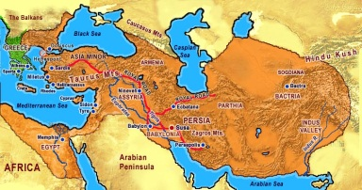
• Mesoamerica: Teotihuacán, Maya city-states
• Andean South America: Moche

EXAMPLE OF PERSIAN EMPIRES – KNOW TWO:
• Achaemenid • Parthian • Sassanid

- Empires and states developed new techniques of imperial administration based, in part, on the success of earlier political forms.
- In order to organize their subjects, the rulers created administrative institutions in many regions.

Required examples of administrative institutions – KNOW ALL:
• Centralized governments • Elaborate legal systems and bureaucracies

- Imperial governments projected military power over larger areas using a variety of techniques.

Required examples of such techniques – KNOW ALL:

• Diplomacy
• Developing supply lines
• Building fortifications, defensive walls, and roads
• Drawing new groups of military officers and soldiers from the local populations or conquered peoples

- Much of the success of the empires rested on their promotion of trade and economic integration by building and maintaining roads and issuing currencies.

- Unique social and economic dimensions developed in imperial societies in Afro-Eurasia and the Americas.
- Cities served as centers of trade, public performance of religious rituals, & political administration for states/empires.
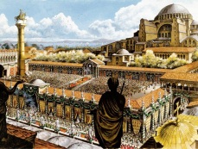
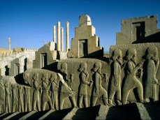
EXAMPLE OF CITIES – KNOW FOUR:

• Persepolis
• Chang’an
• Pataliputra
• Athens
• Carthage
• Rome
• Alexandria
• Constantinople
• Teotihuacán

- The social structures of empires displayed hierarchies that included cultivators, laborers, slaves, artisans, merchants, elites, or caste groups.
- Imperial societies relied on a range of methods to maintain the production of food and provide rewards for the loyalty of the elites.
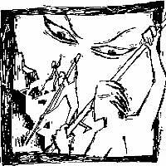
EXAMPLE OF SUCH METHODS – KNOW TWO:

• Corvée
• Slavery
• Rents and tributes
• Peasant communities
• Family and household production

- Patriarchy continued to shape gender and family relations in all imperial societies of this period.

- The Roman, Han, Persian, Mauryan, and Gupta empires created political, cultural, and administrative difficulties that they could not manage, which eventually led to their decline, collapse, and transformation into successor empires or states.
- Through excessive mobilization of resources, imperial governments caused environmental damage and generated social tensions and economic difficulties by concentrating too much wealth in the hands of elites.

EXAMPLE OF ENVIRONMENTAL DAMAGE – KNOW TWO:
• Deforestation • Desertification • Soil erosion • Silted rivers

- External problems resulted from security issues along their frontiers, including the threat of invasions.
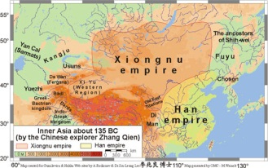
EXAMPLE OF EXTERNAL PROBLEMS ALONG FRONTIERS – KNOW TWO:
• Between Han China and the Xiongnu
• Between the Gupta and the White Huns
• Between the Romans and their northern and eastern neighbors

Key Concept 2.3: Emergence of Transregional Networks of Communication and Exchange
With the organization of large-scale empires, the volume of long-distance trade increased dramatically. Much of this trade resulted from the demand for raw materials and luxury goods. Land and water routes linked many regions of the Eastern Hemisphere. The exchange of people, technology, religious and cultural beliefs, food crops, domesticated animals, and disease pathogens developed alongside the trade in goods across far-flung networks of communication and exchange. In the Americas and Oceania localized networks developed.

- Land and water routes became the basis for transregional trade, communication, and exchange networks in the Eastern Hemisphere.
- Many factors, including the climate and location of the routes, the typical trade goods, and the ethnicity of people involved, shaped the distinctive features of a variety of trade routes.

Required examples of trade routes – KNOW ALL:

• Eurasian Silk Roads
• Trans-Saharan caravan routes
• Indian Ocean sea lanes
• Mediterranean sea lanes

- New technologies facilitated long-distance communication and exchange.
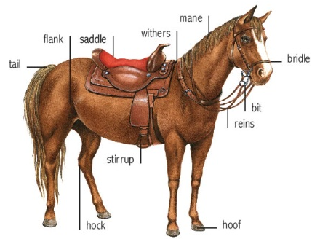
- New technologies permitted the use of domesticated pack animals to transport goods across longer routes.

EXAMPLE OF NEW TECHNOLOGIES – KNOW TWO:
• Yokes • Saddles • Stirrups

EXAMPLE OF DOMESTICATED PACK ANIMALS – KNOW TWO:
• Camels • Oxen • Llamas • Horses

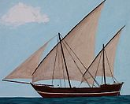
- Innovations in maritime technologies, as well as advanced knowledge of the monsoon winds, stimulated exchanges along maritime routes from East Africa to East Asia.

EXAMPLE OF INNOVATIONS IN MARITIME TECHNOLOGIES – KNOW ONE:
• Lateen sail • Dhow ships

- Alongside the trade in goods, the exchange of people, technology, religious and cultural beliefs, food crops, domesticated animals, and disease pathogens developed across far-flung networks of communication and exchange.
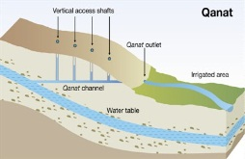
- The spread of crops, including rice and cotton from South Asia to the Middle East, encouraged changes in farming and irrigation techniques.
EXAMPLE OF CHANGES IN FARMING AND IRRIGATION TECHNIQUES:
• The qanat system

- The spread of disease pathogens diminished urban populations and contributed to the decline of some empires.

EXAMPLE OF THE EFFECTS OF THE SPREAD OF DISEASE ON EMPIRES – KNOW ONE:
• The effects of disease on the Roman Empire • The effects of disease on Chinese empires

- Religious and cultural traditions were transformed as they spread.

Required examples of transformed religious and cultural traditions – KNOW ALL:
• Christianity • Hinduism • Buddhism

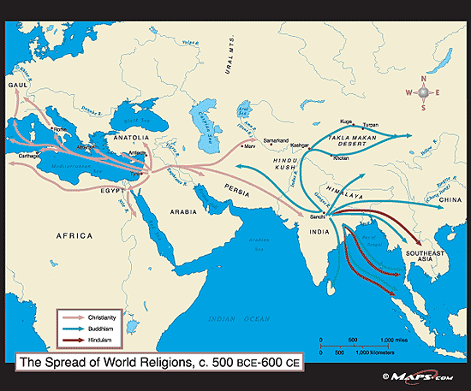
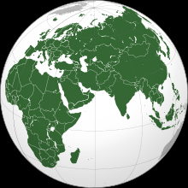
Era 3: Regional & Transregional Interactions, c. 600 C.E. to c. 1450 C.E.

Key Concept 3.1: Expansion and Intensification of Communication and Exchange Networks

  - Improved transportation technologies and commercial practices led to an increased volume of trade, and expanded the geographical range of existing and newly active trade networks.

    - Existing trade routes flourished and promoted the growth of powerful new trading cities.

Required examples of existing trade routes - KNOW ALL:

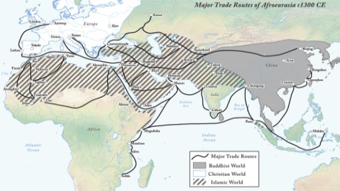
      - The Silk Roads
      - The Mediterranean Sea

      - The Trans-Saharan
      - The Indian Ocean basin
EXAMPLES OF NEW TRADING CITIES - BE ABLE TO LOCATE 5

      - Novgorod
      - Timbuktu
      - The Swahili city-states
      - Hangzhou
      - Calicut
      - Baghdad
      - Melaka
      - Venice
      - Tenochtitlan

    - New trade routes centering on Mesoamerica and the Andes developed.

    - The growth of interregional trade in luxury goods was encouraged by significant innovations in previously existing transportation and commercial technologies, including more sophisticated caravan organization; use of the compass, astrolabe, and larger ship designs in sea travel; and new forms of credit and monetization.

EXAMPLES OF LUXURY GOODS BEING TRADED – BE ABLE TO MAP AT LEAST 3:

      - Silk and cotton textiles
      - Porcelain
      - Spices
      - Precious metals and gems
      - Slaves
      - Exotic animals

EXAMPLES OF TECHNOLOGY/INOVATIONS HELPING LONG DISTANCE TRADE - KNOW ONE:
      - Stirrup • Caravanserai • Camel saddles

EXAMPLES OF NEW TYPES OF BANKING – KNOW ONE:
      - Bills of exchange • Credit • Checks • Banking houses

    - Commercial growth was also facilitated by state practices, trading organizations, and state-sponsored commercial infrastructures like the Grand Canal in China.

EXAMPLES OF STATE PRACTICES - KNOW ONE:
• Minting of coins • Use of paper money

EXAMPLES OF TRADING ORGANIZATIONS:
• Hanseatic League

    - The expansion of empires facilitated Trans-Eurasian trade and communication as new peoples were drawn into their conquerors’ economies and trade networks.

EXAMPLES OF EMPIRES - KNOW TWO:
• China • The Byzantine Empire • The Caliphates • The Mongols

  - The movement of peoples caused environmental and linguistic effects.

    - The expansion and intensification of long-distance trade routes often depended on environmental knowledge and technological adaptations to it.

EXAMPLES OF ENVIRONMENTAL KNOWLEDGE AND TECHNOLOGICAL ADAPTATIONS - KNOW ONE:
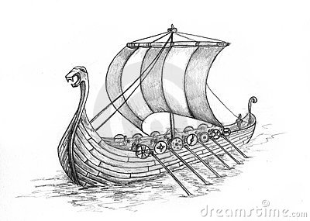
      - The way Scandinavian Vikings used their longships to travel in coastal & open waters as well as in rivers/estuaries
      - The way the Arabs and Berbers adapted camels to travel across and around the Sahara
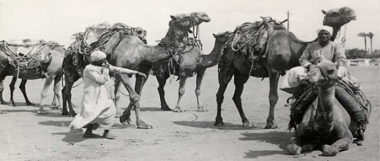
      - The way Central Asian pastoral groups used horses to travel in the steppes

    - Some migrations had a significant environmental impact.

Required examples of migrations and their environmental impact - KNOW ALL:
      - The migration of Bantu-speaking peoples who facilitated transmission of iron technologies and agricultural techniques in Sub-Saharan Africa
      - The maritime migrations of the Polynesian peoples who cultivated transplanted foods and domesticated animals as they moved to new islands

    - Some migrations and commercial contacts led to the diffusion of languages throughout a new region or the emergence of new languages.

EXAMPLES OF THE DIFFUSION OF LANGUAGES - KNOW ONE:
      - The spread of Bantu languages including Swahili • The spread of Turkic and Arabic languages.

  - Cross-cultural exchanges were fostered by the intensification of existing, or the creation of new, networks of trade and communication.

    - Islam, based on the revelations of the prophet Muhammad, developed in the Arabian Peninsula. The beliefs and practices of Islam reflected interactions among Jews, Christians, and Zoroastrians with the local Arabian peoples. Muslim rule expanded to many parts of Afro-Eurasia due to military expansion, and Islam subsequently expanded through the activities of merchants and missionaries.

    - In key places along important trade routes, merchants set up Diasporic communities where they introduced their own cultural traditions into the indigenous culture.

EXAMPLES OF DIASPORIC COMMUNITIES - KNOW ONE:
      - Muslim merchant communities in the Indian Ocean region
      - Chinese merchant communities in Southeast Asia
      - Sogdian merchant communities throughout Central Asia
      - Jewish communities in the Mediterranean, Indian Ocean basin, or along the Silk Roads

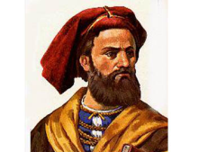
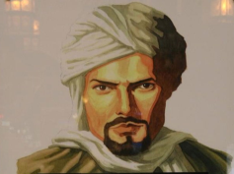
    - The writings of certain interregional travelers illustrate both the extent and the limitations of intercultural knowledge and understanding.

EXAMPLES OF INTERREGIONAL TRAVELERS - KNOW ONE:
      - Ibn Battuta • Marco Polo • Xuanzang

    - Increased cross-cultural interactions resulted in the diffusion of literary, artistic, and cultural traditions.

EXAMPLES OF CULTURAL DIFFUSION - KNOW TWO:
      - The influence of Neoconfucianism and Buddhism in East Asia
      - Hinduism and Buddhism in Southeast Asia
      - Islam in Sub-Saharan Africa and Southeast Asia
      - Toltec/Mexica and Inca traditions in Mesoamerica and Andean America

    - Increased cross-cultural interactions also resulted in the diffusion of scientific and technological traditions.

EXAMPLES OF TECHNOLOGICAL/SCIENTIFIC DIFFUSION - KNOW TWO:
      - The influence of Greek and Indian mathematics on Muslim scholars
      - The return of Greek science and philosophy to Western Europe via Muslim al-Andalus in Iberia
      - The spread of printing & gunpowder technologies from East Asia into the Islamic empires and Western Europe

  - There was continued diffusion of crops and pathogens throughout the Eastern Hemisphere along the trade routes.

    - New foods and agricultural techniques were adopted in populated areas.

EXAMPLES OF NEW FOODS/AGRICULTURAL TECHNIQUES - KNOW ONE:
      - Bananas in Africa
      - New rice varieties in East Asia
      - The spread of cotton, sugar, & citrus throughout Dar al-Islam (the “Islamic World”) & the Mediterranean basin

    - The spread of epidemic diseases, including the Black Death, followed the well-established paths of trade and military conquest.

Key Concept 3.2: Continuity and Innovation of State Forms and Their Interactions

- Empires collapsed and were reconstituted; in some regions new state forms emerged.

- Following the collapse of empires, most reconstituted governments, including the Byzantine Empire and the Chinese dynasties — Sui, Tang, and Song — combined traditional sources of power and legitimacy with innovations better suited to the current circumstances.

EXAMPLES OF TRADITIONAL SOURCES OF POWER AND LEGITIMACY AND INNOVATIONS - KNOW ONE of each:

      - Patriarchy
      - Religion
      - Land-owning elites
      - New methods of taxation
      - Tributary systems
      - Adaptation of religious institutions.

- In some places, new forms of governance emerged, including those developed in various Islamic states, the Mongol Khanates, city-states, and decentralized government (feudalism) in Europe and Japan.

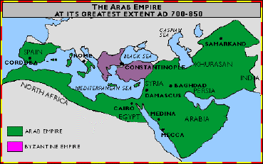
EXAMPLES OF ISLAMIC STATES - KNOW ONE:
      - Abbasids • Muslim Iberia • Delhi Sultanates

EXAMPLES OF CITY STATES - KNOW ONE:
      - In the Italian peninsula
      - In East Africa
      - In Southeast Asia
      - In the Americas

    - Some states synthesized local and borrowed traditions.

EXAMPLES OF LOCAL AND BORROWED TRADITIONS - KNOW ONE:
      - Persian traditions that influenced Islamic states
      - Chinese traditions that influenced states in Japan

    - In the Americas, as in Afro-Eurasia, state systems expanded in scope and reach: Networks of city-states flourished in the Maya region and, at the end of this period, imperial systems were created by the Mexica (Aztecs) and Inca.

- Interregional contacts and conflicts between states & empires encouraged significant technological and cultural transfers.

Required examples of technological and cultural transfers - KNOW ALL:
      - Between Tang China and the Abbasids
      - Across the Mongol empires
      - During the Crusades
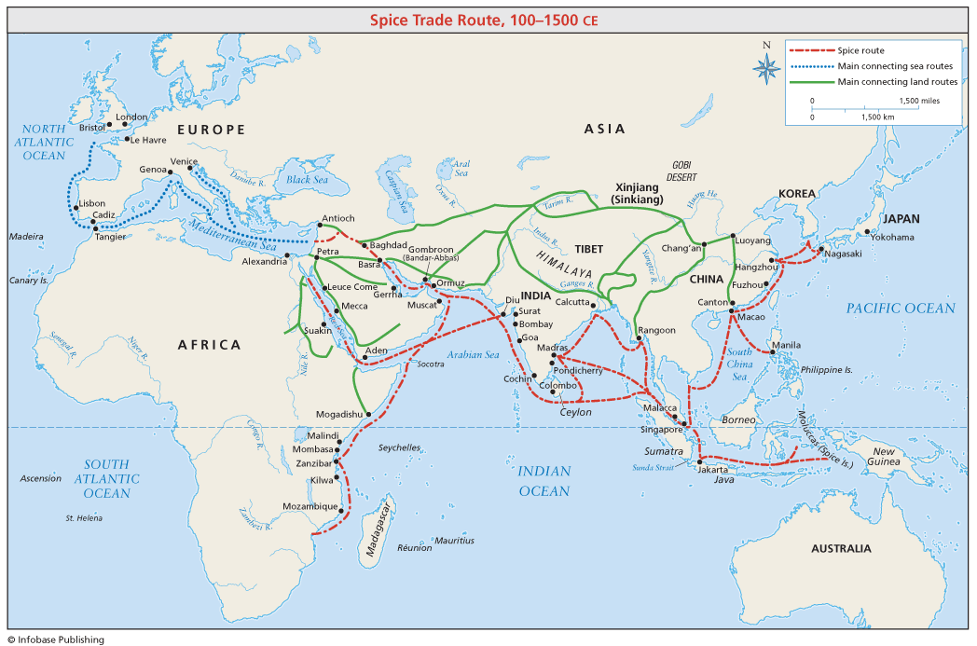

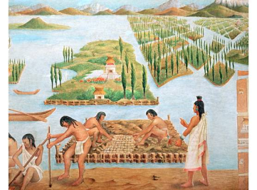
Key Concept 3.3: Increased Economic Productive Capacity and Its Consequences

- Innovations stimulated agricultural and industrial production in many regions.

- Agricultural production increased significantly due to technological Innovations.

EXAMPLES OF TECHNOLOGICAL INNOVATIONS - KNOW TWO:
- Champa rice varieties
- The chinampa systems
- Waru waru agricultural techniques in the Andean areas
- Improved terracing techniques
- The horse collar

- In response to increasing demand in Afro-Eurasia for foreign luxury goods, crops were transported from their indigenous homelands to equivalent climates in other regions.

- Chinese, Persian, and Indian artisans and merchants expanded their production of textiles and porcelains for export; industrial production of iron and steel expanded in China.

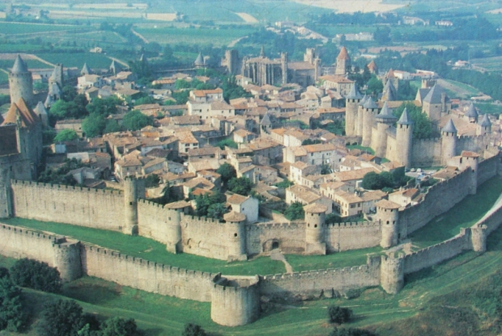
- The fate of cities varied greatly, with periods of significant decline, and with periods of increased urbanization buoyed by rising productivity and expanding trade networks.

- Multiple factors contributed to the declines of urban areas in this period.

Required examples of these factors - KNOW ALL:

      - Invasions
      - Disease
      - The decline of agricultural productivity
      - The Little Ice Age

- Multiple factors contributed to urban revival.

Required examples of these factors - KNOW ALL:
      - The end of invasions
      - The availability of safe and reliable transport
      - The rise of commerce and the warmer temperatures between 800 and 1300
      - Increased agricultural productivity and subsequent rising population
      - Greater availability of labor also contributed to urban growth

- While cities in general continued to play the roles they had played in the past as governmental, religious, and commercial centers, many older cities declined at the same time that numerous new cities emerged to take on these established roles.

- Despite significant continuities in social structures and in methods of production, there were also some important changes in labor management and in the effect of religious conversion on gender relations and family life.

- As in the previous period, there were many forms of labor organization.

Required examples of forms of labor organization - KNOW ALL:

      - Free peasant agriculture
      - Nomadic pastoralism
      - Craft production and guild organization
      - Various forms of coerced and unfree labor
      - Government-imposed labor taxes
      - Military obligations!

- As in the previous period, social structures were shaped largely by class and caste hierarchies. Patriarchy persisted; however, in some areas, women exercised more power and influence, most notably among the Mongols and in West Africa, Japan, and Southeast Asia.

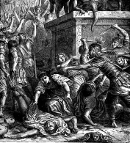
- New forms of coerced labor appeared, including serfdom in Europe and Japan and the elaboration of the mit’a in the Inca Empire. Free peasants resisted attempts to raise dues and taxes by staging revolts. The demand for slaves for both military and domestic purposes increased, particularly in central Eurasia, parts of Africa, and the eastern Mediterranean.

EXAMPLES OF FREE PEASANT REVOLTS - KNOW ONE:
• China • The Byzantine Empire

- The diffusion of Buddhism, Christianity, Islam, and Neoconfucianism often led to significant changes in gender relations and family structure.
Era 4: Global Interactions, c. 1450 to c. 1750

Key Concept 4.1. Globalizing Networks of Communication and Exchange
The interconnection of the Eastern and Western hemispheres made possible by transoceanic voyaging marked a key transformation of this period. Technological innovations helped to make transoceanic connections possible. Changing patterns of long-distance trade included the global circulation of some commodities and the formation of new regional markets and financial centers. Increased transregional and global trade networks facilitated the spread of religion and other elements of culture as well as the migration of large numbers of people. Germs carried to the Americas ravaged the indigenous peoples, while the global exchange of crops and animals altered agriculture, diets, and populations around the planet.

- In the context of the new global circulation of goods, there was an intensification of all existing regional trade networks that brought prosperity and economic disruption to the merchants and governments in the trading regions of the Indian Ocean, Mediterranean, Sahara, and overland Eurasia.

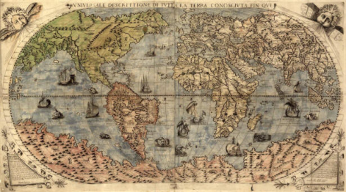
- European technological developments in cartography and navigation built on previous knowledge developed in the classical, Islamic, and Asian worlds, and included the production of new tools, innovations in ship designs, and an improved understanding of global wind and currents patterns — all of which made transoceanic travel and trade possible.

EXAMPLES OF NEW TOOLS – KNOW ONE:
• Astrolabe • Revised maps

EXAMPLE OF INNOVATIONS IN SHIP DESIGNS:
• Caravels

- Remarkable new transoceanic maritime reconnaissance occurred in this period.
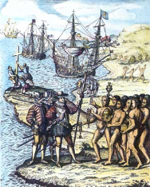
- Official Chinese maritime activity expanded into the Indian Ocean region with the naval voyages led by Ming Admiral Zheng He, which enhanced Chinese prestige.
- Portuguese development of a school for navigation led to increased travel to and trade with West Africa, and resulted in the construction of a global trading-post empire.
- Spanish sponsorship of the first Columbian and subsequent voyages across the Atlantic and Pacific dramatically increased European interest in transoceanic travel and trade.
- Northern Atlantic crossings for fishing and settlements continued and spurred European searches for multiple routes to Asia.
- In Oceania and Polynesia, established exchange and communication networks were not dramatically affected because of infrequent European reconnaissance in the Pacific Ocean.

- The new global circulation of goods was facilitated by royal chartered European monopoly companies that took silver from Spanish colonies in the Americas to purchase Asian goods for the Atlantic markets, but regional markets continued to flourish in Afro-Eurasia by using established commercial practices and new transoceanic shipping services developed by European merchants.
- European merchants’ role in Asian trade was characterized mostly by transporting goods from one Asian country to another market in Asia or the Indian Ocean region.
- Commercialization and the creation of a global economy were intimately connected to new global circulation of silver from the Americas.
- Influenced by mercantilism, joint-stock companies were new methods used by European rulers to control their domestic and colonial economies and by European merchants to compete against one another in global trade.
- The Atlantic system involved the movement of goods, wealth, and free and unfree laborers, and the mixing of African, American, and European cultures and peoples.

- The new connections between the Eastern and Western hemispheres resulted in the Columbian Exchange.
- European colonization of the Americas led to the spread of diseases — including smallpox, measles, and influenza — that were endemic in the Eastern Hemisphere among Amerindian populations and the unintentional transfer of vermin, including mosquitoes and rats.

- American foods became staple crops in various parts of Europe, Asia, and Africa. Cash crops were grown primarily on plantations with coerced labor and were exported mostly to Europe and the Middle East in this period.

EXAMPLES OF AMERICAN FOODS – KNOW TWO:
• Potatoes • Maize • Manioc

EXAMPLES OF CASH CROPS – KNOW BOTH:
• Sugar • Tobacco

- Afro-Eurasian fruit trees, grains, sugar, and domesticated animals were brought by Europeans to the Americas, while other foods were brought by African slaves.

EXAMPLES OF DOMESTICATED ANIMALS – KNOW TWO:
• Horses • Pigs • Cattle

EXAMPLES OF FOODS BROUGHT BY AFRICAN SLAVES – KNOW BOTH:
• Okra • Rice

- Populations in Afro-Eurasia benefited nutritionally from the increased diversity of American food crops.

- European colonization and the introduction of European agriculture and settlements practices in the Americas often affected the physical environment through deforestation and soil depletion.

- The increase in interactions between newly connected hemispheres and intensification of connections within hemispheres expanded the spread and reform of existing religions and created syncretic belief systems and practices.

- As Islam spread to new settings in Afro-Eurasia, believers adapted it to local cultural practices. The split between the Sunni and Shi’a traditions of Islam intensified, and Sufi practices became more widespread.

- The practice of Christianity continued to spread throughout the world and was increasingly diversified by the process of diffusion and the Reformation.

- Buddhism spread within Asia.

- Syncretic and new forms of religion developed.

EXAMPLES OF SYNCRETIC AND NEW FORMS OF RELIGION – KNOW ONE:
• Vodun in the Caribbean • The cults of saints in Latin America • Sikhism in South Asia

- As merchants’ profits increased and governments collected more taxes, funding for the visual and performing arts, even for popular audiences, increased.

- Innovations in visual and performing arts were seen all over the world.

EXAMPLES OF INNOVATIONS IN VISUAL AND PERFORMING ARTS – KNOW TWO:

• Renaissance art in Europe
• Miniature paintings in the M. East and S. Asia
• Wood-block prints in Japan
• Post-conquest codices in Mesoamerica

- Literacy expanded and was accompanied by the proliferation of popular authors, literary forms, and works of literature in Afro-Eurasia.

EXAMPLES OF POPULAR AUTHORS, LITERARY FORMS AND WORKS OF LITERATURE – KNOW TWO:

• Shakespeare
• Cervantes
• Sundiata
• Journey to the West
• Kabuki

----------------------------------------------------------------------------------------------------------------------------------------

Key Concept 4.2: New Forms of Social Organization and Modes of Production
Although the world’s productive systems continued to be heavily centered on agricultural production throughout this period, major changes occurred in agricultural labor, the systems and locations of manufacturing, gender and social structures, and environmental processes. A surge in agricultural productivity resulted from new methods in crop and field rotation and the introduction of new crops. Economic growth also depended on new forms of manufacturing and new commercial patterns, especially in long-distance trade. Political and economic centers within regions shifted, and merchants’ social status tended to rise in various states.
Demographic growth — even in areas such as the Americas, where disease had ravaged the population — was restored by the eighteenth century and surged in many regions, especially with the introduction of American food crops throughout the Eastern Hemisphere. The Columbian Exchange led to new ways of humans interacting with their environments. New forms of coerced and semi-coerced labor emerged in Europe, Africa, and the Americas, and affected ethnic and racial classifications and gender roles.

- Traditional peasant agriculture increased and changed, plantations expanded, and demand for labor increased. These changes both fed and responded to growing global demand for raw materials and finished products.

- Peasant labor intensified in many regions.

EXAMPLES OF THE INTENSIFICATION OF PEASANT LABOR – KNOW ONE:
• The development of frontier settlements in Russian Siberia
• Cotton textile production in India
• Silk textile production in China
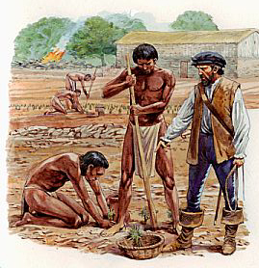
- Slavery in Africa continued both the traditional incorporation of slaves into households and the export of slaves to the Mediterranean and the Indian Ocean.

- The growth of the plantation economy increased the demand for slaves in the Americas.

- Colonial economies in the Americas depended on a range of coerced labor.

EXAMPLES OF COERCED LABOR – KNOW TWO:

• Chattel slavery
• Indentured servitude

• Encomienda and hacienda systems
• The Spanish adaptation of the Inca mit’a

- As new social and political elites changed, they also restructured new ethnic, racial, and gender hierarchies.
- Both imperial conquests and widening global economic opportunities contributed to the formation of new political and economic elites.

EXAMPLES OF NEW ELITES – KNOW TWO:

• The Manchus in China
• Creole elites in Spanish America
• European gentry
• Urban commercial entrepreneurs in all major port cities in the world

- The power of existing political and economic elites fluctuated as they confronted new challenges to their ability to affect the policies of the increasingly powerful monarchs and leaders.

EXAMPLES OF EXISTING ELITES – KNOW ONE:
• The zamindars in the Mughal Empire • The nobility in Europe • The daimyo in Japan

- Some notable gender and family restructuring occurred, including the demographic changes in Africa that resulted from the slave trades.

EXAMPLES OF GENDER AND FAMILY RESTRUCTURING – KNOW ONE:
• The dependence of European men on Southeast Asian women for conducting trade in that region
• The smaller size of European families
- The massive demographic changes in the Americas resulted in new ethnic and racial classifications.

EXAMPLES OF NEW ETHNIC AND RACIAL CLASSIFICATIONS – KNOW TWO:
• Mestizo • Mulatto • Creole

----------------------------------------------------------------------------------------------------------------------------------------

Key Concept 4.3: State Consolidation and Imperial Expansion
Empires expanded and conquered new peoples around the world, but they often had difficulties incorporating culturally, ethnically, and religiously diverse subjects, and administrating widely dispersed territories. Agents of the European powers moved into existing trade networks around the world. In Africa and the greater Indian Ocean, nascent European empires consisted mainly of interconnected trading posts and enclaves. In the Americas, European empires moved more quickly to settlement and territorial control, responding to local demographic and commercial conditions. Moreover, the creation of European empires in the Americas quickly fostered a new Atlantic trade system that included the trans-Atlantic slave trade. Around the world, empires and states of varying sizes pursued strategies of centralization, including more efficient taxation systems that placed strains on peasant producers, sometimes prompting local rebellions. Rulers used public displays of art and architecture to legitimize state power. African states shared certain characteristics with larger Eurasian empires. Changes in African and global trading patterns strengthened some West and Central African states — especially on the coast; this led to the rise of new states and contributed to the decline of states on both the coast and in the interior.
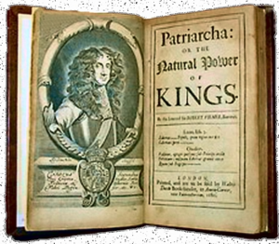
- Rulers used a variety of methods to legitimize and consolidate their power.

- Rulers used the arts to display political power and to legitimize their rule.

EXAMPLES OF THE ARTS AS DISPLAYS OF POLITICAL POWER – KNOW TWO:

• Monumental architecture
• Urban design
• Courtly literature
• The visual arts

- Rulers continued to use religious ideas to legitimize their rule.

EXAMPLES OF THESE RELIGIOUS IDEAS – KNOW TWO:

• European notions of divine right
• Safavid use of Shi’ism
• Aztec (Mexica) practice of human sacrifice
• Songhay promotion of Islam
• Chinese emperors’ public performance of Confucian rituals

- States treated different ethnic and religious groups in ways that utilized their economic contributions while limiting their ability to challenge the authority of the state.

EXAMPLES OF THE DIFFERENTIAL TREATMENT OF ETHNIC AND RELIGIOUS GROUPS – KNOW TWO
• Ottoman treatment of non-Muslim subjects
• Manchu policies toward Chinese
• Spanish creation of a separate “Republica de Indios”

- Recruitment and use of bureaucratic elites, as well as the development of military professionals, became more common among rulers who wanted to maintain centralized control over their populations and resources.

EXAMPLES OF BUREAUCRATIC ELITES OR MILITARY PROFESSIONALS – KNOW TWO

• Ottoman devshirme
• Chinese examination system
• Salaried samurai
• Ottomans
• Russians

- Rulers used tribute collection and tax farming to generate revenue for territorial expansion.

- Imperial expansion relied on the increased use of gunpowder, cannons, and armed trade to establish large empires in both hemispheres.

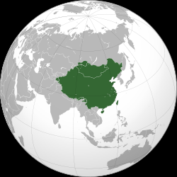
- Europeans established new trading-post empires in Africa and Asia, which proved profitable for the rulers and merchants involved in new global trade networks, but these empires also affected the power of the states in interior West and Central Africa.

- Land empires expanded dramatically in size.

Required examples of land empires – KNOW ALL:
• Manchu • Mughals

- European states established new maritime empires in the Americas.

Required examples of maritime empires – KNOW ALL:

• Portuguese
• Spanish
• Dutch
• French
• British

- Competition over trade routes, state rivalries, and local resistance all provided significant challenges to state consolidation and expansion.
EXAMPLES OF COMPETITION OVER TRADE ROUTES – KNOW ONE:
• Omani-European rivalry in the Indian Ocean • Piracy in the Caribbean

EXAMPLES OF STATE RIVALRIES – KNOW ONE:
• Thirty Years War • Ottoman-Safavid conflict

EXAMPLES OF LOCAL RESISTANCE – KNOW TWO:
• Food riots • Samurai revolts • Peasant uprisings
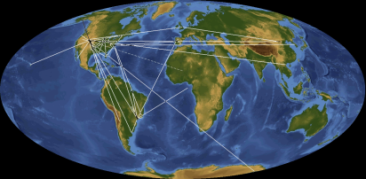
Era 5: Industrialization & Global Integration, c. 1750 to c. 1900

Key Concept 5.1: Industrialization and Global Capitalism
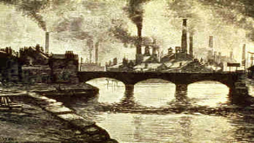
Industrialization fundamentally altered the production of goods around the world. It not only changed how goods were produced and consumed, as well as what was considered a “good,” but it also had far-reaching effects on the global economy, social relations, and culture. Although it is common to speak of an “Industrial Revolution,” the process of industrialization was a gradual one that unfolded over the course of the eighteenth and nineteenth centuries, eventually becoming global.

- Industrialization fundamentally changed how goods were produced.

- A variety of factors led to the rise of industrial production.

Required examples of factors leading to the rise of industrial production – KNOW ALL:
- Europe’s location on the Atlantic Ocean
- The geographical distribution of coal, iron and timber
- European demographic changes
- Urbanization
- Improved agricultural productivity
- Legal protection of private property
- An abundance of rivers and canals
- Access to foreign resources
- The accumulation of capital

- The development of machines, including steam engines and the internal combustion engine, made it possible to exploit vast new resources of energy stored in fossil fuels, specifically coal and oil. The “fossil fuels” revolution greatly increased the energy available to human societies.
- The development of the factory system concentrated labor in a single location and led to an increasing degree of specialization of labor.
- As the new methods of industrial production became more common in parts of northwestern Europe, they spread to other parts of Europe and the United States, Russia, and Japan.
- The “second industrial revolution” led to new methods in the production of steel, chemicals, electricity and precision machinery during the second half of the nineteenth century.

- New patterns of global trade and production developed and further integrated the global economy as industrialists sought raw materials and new markets for the increasing amount and array of goods produced in their factories.
- The need for raw materials for the factories and increased food supplies for the growing population in urban centers led to the growth of export economies around the world that specialized in mass producing single natural resources. The profits from these raw materials were used to purchase finished goods.

EXAMPLES OF THE PRODUCTION AND EXPORT OF SINGLE NATURAL RESOURCES – KNOW THREE:
- Cotton
- Rubber
- Palm oil
- Sugar
- Wheat
- Meat
- Guano
- Metals and minerals

- The rapid development of industrial production contributed to the decline of economically productive, agriculturally based economies.

EXAMPLE OF A DECLINING AGRICULTURALLY BASED ECONOMY
- Textile production in India

- The rapid increases in productivity caused by industrial production encouraged industrialized states to seek out new consumer markets for their finished goods.

EXAMPLE OF NEW CONSUMER MARKETS
- British and French attempts to “open up” the Chinese market during the nineteenth century

- The need for specialized and limited metals for industrial production, as well as the global demand for gold, silver and diamonds as forms of wealth, led to the development of extensive mining centers.
EXAMPLE OF MINING CENTERS – KNOW ONE:
- Copper mines in Mexico
- Gold and diamond mines in South Africa

- To facilitate investments at all levels of industrial production, financiers developed and expanded various financial institutions.

- The ideological inspiration for economic changes lies in the development of capitalism and classical liberalism associated with Adam Smith and John Stuart Mill.
- Financial instruments expanded.
EXAMPLES OF FINANCIAL INSTRUMENTS – KNOW ONE:

- Stock markets
- Insurance
- Gold standard
- Limited liability corporations

- The global nature of trade and production contributed to the proliferation of large-scale transnational businesses.

EXAMPLES OF TRANSNATIONAL BUSINESSES – KNOW BOTH:
- The United Fruit Company
- The HSBC — Hong Kong and Shanghai Banking Corporation

- There were major developments in transportation and communication.

Required examples of developments in transportation and communication – KNOW ALL:

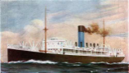
- Railroads
- Steamships
- Telegraphs
- Canals

- The development and spread of global capitalism led to a variety of responses.
- In industrialized states, many workers organized themselves to improve working conditions, limit hours, and gain higher wages, while others opposed capitalist exploitation of workers by promoting alternative visions of society.

EXAMPLES OF ALTERNATIVE VISIONS – KNOW TWO:
- Utopian socialism ● Marxism ● Anarchism

- In Qing China and the Ottoman Empire, some members of the government resisted economic change and attempted to maintain preindustrial forms of economic production.
- In a small number of states, governments promoted their own state-sponsored visions of industrialization.

EXAMPLES OF STATE-SPONSORED VISIONS OF INDUSTRIALIZATION – KNOW TWO:

- The economic reforms of Meiji Japan
- The development of factories and railroads in Tsarist Russia
- China’s Self- Strengthening Movement
- Muhammad Ali’s development of a cotton textile industry in Egypt

- In response to criticisms of industrial global capitalism, some governments mitigated the negative effects of industrial capitalism by promoting various types of reforms.

EXAMPLES OF REFORMS – KNOW TWO:
- State pensions & public health in Germany ● Exp. of suffrage in Britain ● Public ed. in many states

- The ways in which people organized themselves into societies also underwent significant transformations in industrialized states due to the fundamental restructuring of the global economy.

- New social classes, including the middle class and the industrial working class, developed.
- Family dynamics, gender roles, and demographics changed in response to industrialization.
- Rapid urbanization that accompanied global capitalism often led to unsanitary conditions, as well as to new forms of community.

Key Concept 5.2: Imperialism and Nation-State Formation
As states industrialized during this period, they also expanded their existing overseas colonies and established new types of colonies and transoceanic empires. Regional warfare and diplomacy both resulted in and were affected by this process of modern empire building. The process was led mostly by Europe, although not all states were affected equally, which led to an increase of European influence around the world. The United States and Japan also participated in this process. The growth of new empires challenged the power of existing land-based empires of Eurasia. New ideas about nationalism, race, gender, class, and culture also developed that facilitated the spread of transoceanic empires, as well as justified anti-imperial resistance and the formation of new national identities.
- Industrializing powers established transoceanic empires.

- States with existing colonies strengthened their control over those colonies.

EXAMPLES OF STATES WITH EXISTING COLONIES – KNOW BOTH:
- British in India ● Dutch in Indonesia

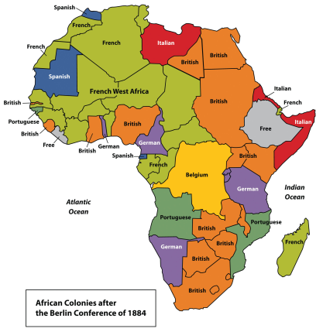
- European states, as well as the Americans and the Japanese, established empires throughout Asia and the Pacific, while Spanish and Portuguese influence declined.

EXAMPLES OF EUROPEAN STATES THAT ESTABLISHED EMPIRES – KNOW THREE:

- British
- Dutch
- French
- German
- Russian

- Many European states used both warfare and diplomacy to establish empires in Africa.

EXAMPLES OF EUROPEAN STATES THAT ESTABLISHED EMPIRES IN AFRICA – KNOW ONE:
- Britain in West Africa ● Belgium in the Congo

- In some parts of their empires, Europeans established settler colonies.

EXAMPLES OF EUROPEANS WHO ESTABLISHED SETTLER COLONIES – KNOW ONE:
- The British in southern Africa, Australia, and New Zealand ● The French in Algeria

- In other parts of the world, industrialized states practiced economic imperialism.

EXAMPLES OF INDUSTRIALIZED STATES PRACTICING ECONOMIC IMPERIALISM – KNOW BOTH:
- The British and French expanding their influence in China through the Opium Wars
- The British and the United States investing heavily in Latin America

- Imperialism influenced state formation and contraction around the world.
- The expansion of U.S. and European influence over Tokugawa Japan led to the emergence of Meiji Japan.
- The United States and Russia emulated European transoceanic imperialism by expanding their land borders and conquering neighboring territories.
- Anti-imperial resistance led to the contraction of the Ottoman Empire.

EXAMPLES OF THE CONTRACTION OF THE OTTOMAN EMPIRE – KNOW ONE:
- The establishment of independent states in the Balkans
- Semi-independence in Egypt, French and Italian colonies in North Africa
- Later British influence in Egypt

- New states developed on the edges of existing empires.

EXAMPLES OF SUCH NEW STATES – KNOW ONE:

- The Cherokee Nation
- Siam
- Hawaii
- The Zulu Kingdom

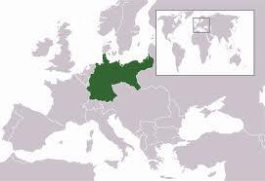
- The development and spread of nationalism as an ideology fostered new communal identities.

EXAMPLES OF NATIONALISM– KNOW ONE:
- The German nation ● Filipino nationalism ● Liberian nationalism

- New racial ideologies, especially Social Darwinism, facilitated and justified imperialism.

Key Concept 5.3: Nationalism, Revolution, and Reform
The eighteenth century marked the beginning of an intense period of revolution and rebellion against existing governments, and the establishment of new nation-states around the world. Enlightenment thought and the resistance of colonized peoples to imperial centers shaped this revolutionary activity. These rebellions sometimes resulted in the formation of new states and stimulated the development of new ideologies. These new ideas in turn further stimulated the revolutionary and anti-imperial tendencies of this period.
- The rise and diffusion of Enlightenment thought that questioned established traditions in all areas of life often preceded the revolutions and rebellions against existing governments.

- Thinkers applied new ways of understanding the natural world to human relationships, encouraging observation and inference in all spheres of life.

EXAMPLES OF SUCH THINKERS – KNOW ONE:
- Voltaire ● Rousseau

- Intellectuals critiqued the role that religion played in public life, insisting on the importance of reason as opposed to revelation.
- Enlightenment thinkers developed new political ideas about the individual, natural rights, and the social contract.

EXAMPLES OF ENLIGHTENMENT THINKERS – KNOW ONE:
- Locke ● Montesquieu

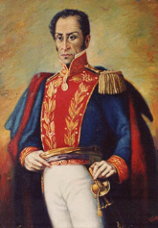
- The ideas of Enlightenment thinkers influenced resistance to existing political authority, as reflected in revolutionary documents.

Required examples of revolutionary documents – KNOW ALL:
- The American Declaration of Independence
- The French Declaration of the Rights of Man and Citizen
- Bolivar’s Jamaica Letter

- These ideas influenced many people to challenge existing notions of social relations, which led to the expansion of rights as seen in expanded suffrage, the abolition of slavery and the end of serfdom, as their ideas were implemented.

- Beginning in the eighteenth century, peoples around the world developed a new sense of commonality based on language, religion, social customs and territory. These newly imagined national communities linked this identity with the borders of the state, while governments used this idea to unite diverse populations.

- Increasing discontent with imperial rule propelled reformist and revolutionary movements.
- Subjects challenged the centralized imperial governments.

EXAMPLES OF SUBJECTS CHALLENGING IMPERIAL GOVERNMENT:
- The challenge of the Marathas to the Mughal Sultans

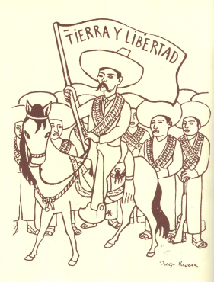
- American colonial subjects led a series of rebellions, which facilitated the emergence of independent states in the United States, Haiti, and mainland Latin America. French subjects rebelled against their monarchy.

Required examples of rebellions – KNOW ALL:

- American Revolution
- French Revolution
- Haitian Revolution
- Latin American independence movements

- Slave resistance challenged existing authorities in the Americas.

EXAMPLES OF SLAVE RESISTANCE:
- The establishment of Maroon societies.

- Increasing questions about political authority and growing nationalism contributed to anticolonial movements.

EXAMPLES OF ANTICOLONIAL MOVEMENTS – KNOW ONE:
- The Indian Revolt of 1857 ● The Boxer Rebellion

- Some of the rebellions were influenced by religious ideas and millenarianism.

EXAMPLES OF SUCH REBELLIONS – KNOW ONE:
- The Taiping Rebellion ● The Ghost Dance ● The Xhosa Cattle-Killing Movement
- Responses to increasingly frequent rebellions led to reforms in imperial policies.

EXAMPLES OF REFORMS – KNOW ONE:
- The Tanzimat movement ● The Self-Strengthening Movement
- The global spread of European political and social thought and the increasing number of rebellions stimulated new transnational ideologies and solidarities.
- Discontent with monarchist and imperial rule encouraged the development of political ideologies, including liberalism, socialism, and communism.
- Demands for women’s suffrage and an emergent feminism challenged political and gender hierarchies.

EXAMPLES OF SUCH DEMANDS – KNOW ONE:
- Mary Wollstonecraft’s A Vindication of the Rights of Woman
- Olympe de Gouge’s “Declaration of the Rights of Women and the Female Citizen”
- The resolutions passed at the Seneca Falls Conference in 1848

Key Concept 5.4: Global Migration
Migration patterns changed dramatically throughout this period, and the numbers of migrants increased significantly. These changes were closely connected to the development of transoceanic empires and a global capitalist economy. In some cases, people benefited economically from migration, while other people were seen simply as commodities to be transported. In both cases, migration produced dramatically different societies for both sending and receiving societies, and presented challenges to governments in fostering national identities and regulating the flow of people.

- Migration in many cases was influenced by changes in demography in both industrialized and unindustrialized societies that presented challenges to existing patterns of living.

- Changes in food production and improved medical conditions contributed to a significant global rise in population.
- Because of the nature of the new modes of transportation, both internal and external migrants increasingly relocated to cities. This pattern contributed to the significant global urbanization of the nineteenth century.
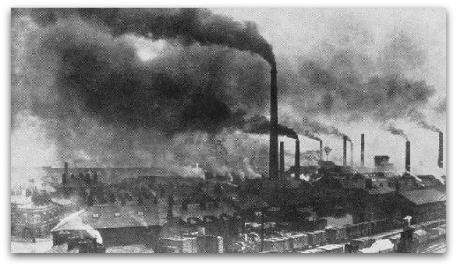
- Migrants relocated for a variety of reasons.

- Many individuals chose freely to relocate, often in search of work.

EXAMPLES OF SUCH MIGRANTS – KNOW BOTH:
- Manual laborers
- Specialized professionals

- The new global capitalist economy continued to rely on coerced and semi-coerced labor migration.

Required examples of coerced and semi-coerced labor migration – KNOW ALL:
- Slavery ● Chinese and Indian indentured servitude ● Convict labor

- While many migrants permanently relocated, a significant number of temporary and seasonal migrants returned to their home societies.

EXAMPLES OF SUCH TEMPORARY AND SEASONAL MIGRANTS – KNOW ONE:
- Japanese agricultural workers in the Pacific
- Lebanese merchants in the Americas
- Italians in Argentina

- The large-scale nature of migration, especially in the nineteenth century, produced a variety of consequences and reactions to the increasingly diverse societies on the part of migrants and the existing populations.
- Due to the physical nature of the labor in demand, migrants tended to be male, leaving women to take on new roles in the home society that had been formerly occupied by men.
- Migrants often created ethnic enclaves in different parts of the world which helped transplant their culture into new environments and facilitated the development of migrant support networks.

EXAMPLES OF MIGRANT ETHNIC ENCLAVES IN DIFFERENT PARTS OF THE WORLD – KNOW ONE:
- Chinese in Southeast Asia, the Caribbean, South America, and North America
- Indians in East and southern Africa, the Caribbean, and Southeast Asia

- Receiving societies did not always embrace immigrants, as seen in the various degrees of ethnic and racial prejudice and the ways states attempted to regulate the increased flow of people across their borders.

EXAMPLES OF THE REGULATION OF IMMIGRANTS – KNOW ONE:
- The Chinese Exclusion Acts ● The White Australia Policy
Era 6: Accelerating Global Change and Realignments, c. 1900 to the Present

Key Concept 6.1: Science and the Environment
Rapid advances in science altered the understanding of the universe and the natural world and led to the development of new technologies. These changes enabled unprecedented population growth, which altered how humans interacted with the environment and threatened delicate ecological balances at local, regional, and global levels.

- Researchers made rapid advances in science that spread throughout the world, assisted by the development of new technology.

- New modes of communication and transportation virtually eliminated the problem of geographic distance.
- New scientific paradigms transformed human understanding of the world.
EXAMPLE OF NEW SCIENTIFIC PARADIGMS – KNOW TWO:
• The theory of relativity
• Quantum mechanics
• The Big Bang theory
• Psychology

- The Green Revolution produced food for the earth’s growing population as it spread chemically and genetically enhanced forms of agriculture.
- Medical innovations increased the ability of humans to survive.

EXAMPLE OF MEDICAL INNOVATIONS – KNOW TWO:
• Polio vaccine • Antibiotics • Artificial heart

- Energy technologies including the use of oil and nuclear power raised productivity and increased the production of material goods.

- As the global population expanded at an unprecedented rate, humans fundamentally changed their relationship with the environment.

- Humans exploited and competed over the earth’s finite resources more intensely than ever before in human history.
- Global warming was a major consequence of the release of greenhouse gases and other pollutants into the atmosphere.
- Pollution threatened the world’s supply of water and clean air. Deforestation and desertification were continuing consequences of the human impact on the environment. Rates of extinction of other species accelerated sharply.

- Disease, scientific innovations, and conflict led to demographic shifts.

- Diseases associated with poverty persisted, while other diseases emerged as new epidemics and threats to human survival. In addition, changing lifestyles and increased longevity led to higher incidence of certain diseases.
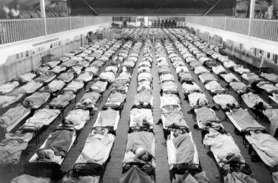
EXAMPLE OF DISEASES ASSOCIATED WITH POVERTY – KNOW TWO:
• Malaria • Tuberculosis • Cholera

EXAMPLE OF EMERGENT EPIDEMIC DISEASES – KNOW ONE:
• The 1918 influenza pandemic • Ebola • HIV/AIDS

EXAMPLE OF DISEASES ASSOCIATED WITH CHANGING LIFESTYLES – KNOW TWO:
• Diabetes • Heart disease • Alzheimer’s disease

- More effective forms of birth control gave women greater control over fertility and transformed sexual practices.
- Improved military technology and new tactics led to increased levels of wartime casualties.

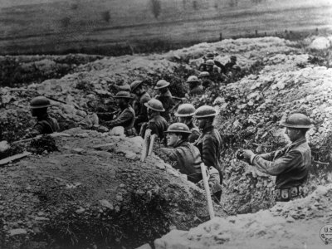
EXAMPLE OF IMPROVED MILITARY TECHNOLOGY – KNOW TWO:
• Tanks • Airplanes • the atomic bomb

EXAMPLE OF NEW TACTICS – KNOW ONE:
• Trench warfare • Firebombing

EXAMPLE OF WARTIME CASUALTIES – KNOW TWO:
• Nanjing • Dresden • Hiroshima

Key Concept 6.2: Global Conflicts and Their Consequences
At the beginning of the twentieth century, a European-dominated global political order existed, which also included the United States, Russia, and Japan. Over the course of the century, peoples and states around the world challenged this order in ways that sought to redistribute power within the existing order and to restructure empires, while those peoples and states in power attempted to maintain the status quo. Other peoples and states sought to overturn the political order itself. These challenges to, and the attempts to maintain, the political order manifested themselves in an unprecedented level of conflict with high human casualties. In the context of these conflicts, many regimes in both older and newer states struggled with maintaining political stability and were challenged by internal and external factors, including ethnic and religious conflicts, secessionist movements, territorial partitions, economic dependency, and the legacies of colonialism.

- Europe dominated the global political order at the beginning of the twentieth century, but both land-based and transoceanic empires gave way to new forms of transregional political organization by the century’s end.

- The older land-based Ottoman, Russian, & Qing empires collapsed due to a combination of internal & external factors.

EXAMPLE OF INTERNAL AND EXTERNAL FACTORS – KNOW TWO:
• Economic hardship
• Political and social discontent
• Technological stagnation
• Military defeat

- Some colonies negotiated their independence.

EXAMPLE OF NEGOTIATED INDEPENDENCE – KNOW ONE:
• India from the British Empire • the Gold Coast from the British Empire

- Some colonies achieved independence through armed struggle.

EXAMPLE OF INDEPENDENCE THROUGH ARMED STRUGGLE – KNOW ONE:
• Algeria and Vietnam from the French empire • Angola from the Portuguese empire

- Emerging ideologies of anti-imperialism contributed to the dissolution of empires and the restructuring of states.

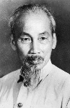
- Nationalist leaders in Asia and Africa challenged imperial rule.
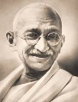
EXAMPLE OF NATIONALIST LEADERS – KNOW TWO:
• Mohandas Gandhi • Kwame Nkrumah • Ho Chi Minh

- Regional, religious, and ethnic movements challenged both colonial rule and inherited imperial boundaries.

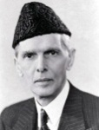
EXAMPLE OF REGIONAL, RELIGIOUS, AND ETHNIC MOVEMENTS – KNOW ONE:
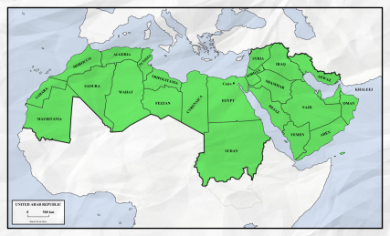
• Muhammad Ali Jinnah
• The Québécois separatist movement
• The Biafra secessionist movement

- Transnational movements sought to unite people across national boundaries.

EXAMPLE OF TRANSNATIONAL MOVEMENTS – KNOW TWO:
• Communism • Pan-Arabism • Pan-Africanism

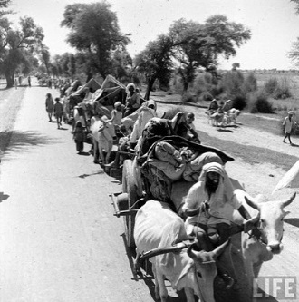
- Movements to redistribute land and resources developed within states in Africa, Asia, and Latin America, sometimes advocating communism and socialism.

- Political changes were accompanied by major demographic and social consequences.

- The redrawing of old colonial boundaries led to population resettlements.

EXAMPLE OF POPULATION RESETTLEMENTS – KNOW TWO:
• The India/Pakistan partition
• The Zionist Jewish settlement of Palestine
• The division of the Middle East into mandatory states

- The migration of former colonial subjects to imperial metropoles maintained cultural and economic ties between the colony and the metropole even after the dissolution of empires.

EXAMPLE OF SUCH MIGRATIONS – KNOW ONE:
• South Asians to Britain • Algerians to France • Filipinos to the United States
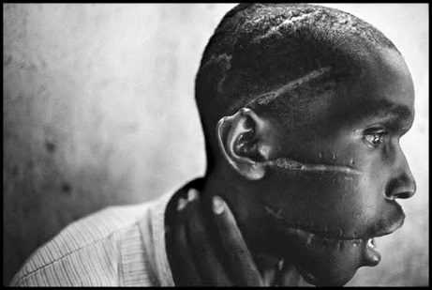
- The proliferation of conflicts led to various forms of ethnic violence and the displacement of peoples resulting in refugee populations.

EXAMPLE OF SUCH ETHNIC VIOLENCE – KNOW TWO:
• Armenia
• the Holocaust
• Cambodia
• Rwanda

EXAMPLE OF DISPLACEMENT OF PEOPLES – KNOW TWO:
• Palestinians • Darfurians

- Military conflicts occurred on an unprecedented global scale.

- World War I and World War II were the first “total wars.” Governments used ideologies, including fascism, nationalism and communism, to mobilize all of their state’s resources, including peoples, both in the home countries and the colonies or former colonies, for the purpose of waging war. Governments also used a variety of strategies, including political speeches, art, media, and intensified forms of nationalism, to mobilize these populations.

EXAMPLE OF MOBILIZATION OF A STATE’S RESOURCES – KNOW ONE:
• The Gurkha soldiers in India
• The ANZAC troops in Australia
• Military conscription

- The sources of global conflict in the first half of the century varied.

Required examples of the sources of global conflict – KNOW ALL:
• Imperialist expansion by European powers and Japan
• Competition for resources
• Ethnic conflict
• Great power rivalries between Great Britain and Germany
• Nationalist ideologies
• The economic crisis engendered by the Great Depression.

- The global balance of economic and political power shifted after the end of World War II and rapidly evolved into the Cold War. The United States and the Soviet Union emerged as superpowers, which led to ideological struggles between capitalism and communism throughout the globe.
- The Cold War produced new military alliances, including NATO and the Warsaw Pact, and promoted proxy wars in Latin America, Africa, and Asia.
- The dissolution of the Soviet Union effectively ended the Cold War.

- Although conflict dominated much of the twentieth century, many individuals and groups — including states — opposed this trend. Some individuals and groups, however, intensified the conflicts.

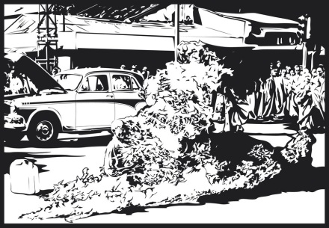
- Groups and individuals challenged the many wars of the century, and some promoted the practice of nonviolence as a way to bring about political change.

EXAMPLE OF GROUPS AND INDIVIDUALS WHO CHALLENGED WAR – KNOW ONE:
• Picasso in his Guernica
• The antinuclear movement during the Cold War
• Thich Quang Duc by self-immolation

EXAMPLE OF NONVIOLENCE – KNOW BOTH:
• Gandhi • Martin Luther King

- Groups and individuals opposed and promoted alternatives to the existing economic, political, and social orders.

EXAMPLE OF SUCH GROUPS AND INDIVIDUALS – KNOW TWO:
• Communist leaders such as Vladimir Lenin and Mao Zedong
• The Non-Aligned Movement, which presented an alternative political bloc to the Cold War
• The Anti-Apartheid Movement in South Africa
• Participants in the global uprisings of 1968
• The Tiananmen Square protesters that promoted democracy in China
- Militaries & militarized states often responded to the proliferation of conflicts in ways that further intensified conflict.

EXAMPLE OF RESPONSES THAT INTENSIFIED CONFLICT – KNOW ONE:
• The promotion of military dictatorship in Chile, Spain, and Uganda
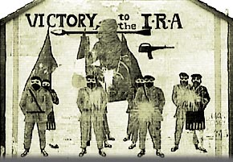
• The United States’ promotion of a New World Order after the Cold War
• The buildup of the “military-industrial complex” and arms trading

- More movements used violence against civilians to achieve political aims.

EXAMPLE OF MOVEMENTS WHO USED VIOLENCE – KNOW TWO:
• IRA • ETA • Al-Qaeda

- Global conflicts had a profound influence on popular culture.

EXAMPLE OF POPULAR CULTURE INFLUENCED BY GLOBAL CONFLICTS – KNOW ONE:
• Dada
• James Bond
• Socialist Realism
• Video games

Key Concept 6.3 New Conceptualizations of Global Economy, Society, and Culture
The twentieth century witnessed a great deal of warfare and the collapse of the global economy in the 1930s. In response to these challenges, the role of state in the domestic economy fluctuated, and new institutions of global governance emerged and continued to develop throughout the century. Scientific breakthroughs, new technologies, increasing levels of integration, changing relationships between humans and the environment, and the frequency of political conflict all contributed to global developments in which people crafted new understandings of society, culture, and historical interpretations. These new understandings often manifested themselves in, and were reinforced by, new forms of cultural production. Institutions of global governance both shaped and adapted to these social conditions.

- States responded in a variety of ways to the economic challenges of the twentieth century.

- In the Communist states of the Soviet Union and China, governments controlled their national economies.

EXAMPLE OF COMMUNIST GOVERNMENTS CONTROLLING THEIR NATIONAL ECONOMIES – KNOW BOTH:
• the Five-Year Plans • the Great Leap Forward

- At the beginning of the century in the United States and parts of Europe, governments played a minimal role in their national economies. With the onset of the Great Depression, governments began to take a more active role in economic life.

EXAMPLE OF GOVERNMENT INTERVENTION IN THE ECONOMY – KNOW ONE:
• the New Deal • the Fascist corporatist economy

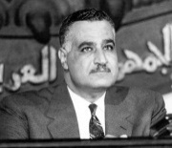
- In newly independent states after World War II, governments often took on a strong role in guiding economic life to promote development.

EXAMPLE OF GOVERNMENTS GUIDING ECONOMIC LIFE – KNOW ONE:
• Nasser’s promotion of economic development in Egypt
• The encouragement of export-oriented economies in East Asia

- At the end of the twentieth century, many governments encouraged free market economic policies and promoted economic liberalization.

EXAMPLE OF GOVERNMENTS ENCOURAGING FREE MARKET POLICIES – KNOW TWO:

• The United States beginning with Reagan
• Britain under Margaret Thatcher
• China under Deng Xiaoping
• Chile under Pinochet

- States, communities, and individuals became increasingly interdependent, a process facilitated by the growth of institutions of global governance.

- New international organizations formed to maintain world peace and to facilitate international cooperation.

EXAMPLE OF NEW INTERNATIONAL ORGANIZATIONS – KNOW TWO:
• the League of Nations • the United Nations • the International Criminal Court

- New economic institutions sought to spread the principles and practices associated with free market economics throughout the world.

EXAMPLE OF NEW ECONOMIC INSTITUTIONS – KNOW TWO:
• The International Monetary Fund (IMF) • World Bank • World Trade Organization (WTO)

- Humanitarian organizations developed to respond to humanitarian crises throughout the world.

EXAMPLE OF HUMANITARIAN ORGANIZATIONS – KNOW TWO:

• UNICEF
• The Red Cross
• Amnesty International
• Doctors Without Borders
• World Health Organization (WHO)

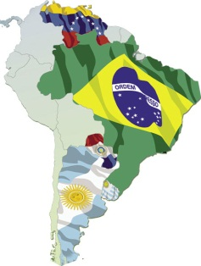
- Regional trade agreements created regional trading blocs designed to promote the movement of capital and goods across national borders.

EXAMPLE OF REGIONAL TRADE AGREEMENTS – KNOW ONE:
• The European Union • NAFTA • ASEAN • Mercosur

- Multinational corporations began to challenge state authority and autonomy.

EXAMPLE OF MULTINATIONAL CORPORATIONS – KNOW ONE:
• Royal Dutch Shell • Sony • Coca-Cola

- Movements throughout the world protested the inequality of environmental & economic consequences of global integration.

EXAMPLE OF PROTEST MOVEMENTS – KNOW ONE:
• Greenpeace • Green Belt in Kenya • Earth Day

- People conceptualized society and culture in new ways; some challenged old assumptions about race, class, gender, and religion, often using new technologies to spread reconfigured traditions.

- The notion of human rights gained traction throughout the world.

EXAMPLE OF HUMAN RIGHTS – KNOW ONE:

• The U.N. Universal Declaration of Human Rights
• Women’s rights
• The end of the White Australia Policy

- Increased interactions among diverse peoples sometimes led to the formation of new cultural identities and exclusionary reactions.

EXAMPLE OF NEW CULTURAL IDENTITIES:
• Negritude

EXAMPLE OF EXCLUSIONARY REACTIONS – KNOW ONE:
• Xenophobia • Race riots • Citizenship restrictions

- Believers developed new forms of spirituality and chose to emphasize particular aspects of practice within existing faiths and apply them to political issues.
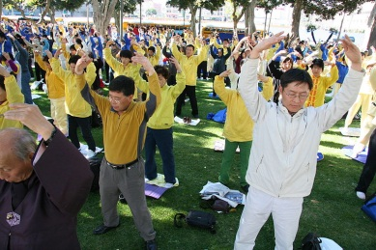
EXAMPLE OF NEW FORMS OF SPIRITUALITY – KNOW ONE:
• New Age Religions • Hare Krishna • Falun Gong

EXAMPLE OF APPLICATION OF RELIGION TO POLITICAL ISSUES – KNOW ONE:
• Fundamentalist movements • Liberation Theology

- Popular and consumer culture became global.

- Sports were more widely practiced and reflected national and social aspirations.
EXAMPLE OF SUCH SPORTS – KNOW ONE:
• World Cup Soccer • Cricket • the Olympics

- Changes in communication and transportation technology enabled the widespread diffusion of music and film.

EXAMPLE OF THE DIFFUSION OF MUSIC AND FILM – KNOW ONE:
• Reggae • Bollywood

