Foundations Review Sheet

Key Terms/Main Ideas
** Remember do not just look up the definition… understand how each can be applied, as well as the significance and impact each have had on our unit of study**

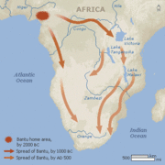
- Five Themes of Geography
- Physical Geography
- Human Geography
- Physical Map
- Political Map
- Geographer
- Archaeologist
- Historian
- Paleolithic Age
- Neolithic Age
- Bantu Migrations
- Nomads
- Hunter-Gatherer
- Domestication
- Specialization
- Subsistence Farming
- Slash-and-Burn Agriculture
- Barter
- Traditional Economy
- Characteristics of Civilization

Essential Questions
- How can geography impact human lives?
- What was early man’s greatest achievement and why?
- Why were domesticating plants and animals important to agricultural people?
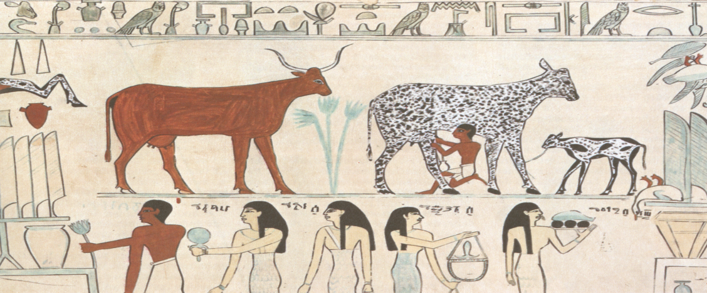
- What is the significance of cave paintings to early man?
- Describe traditional African society: religion, art, politics, economics, and social structure

