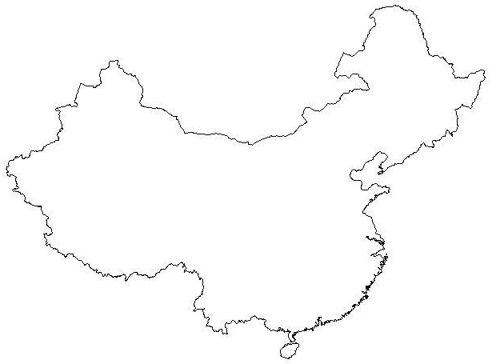
Directions: label, draw, shade, color, or whatever you’re asked to do. A fair amount of accuracy is necessary to earn all of your points.

- Draw and label the Yangtze River.

- Draw and label the Yellow River.

- Draw and label the Himalayas.

- Shade in the area held by Han.

- Draw (by adding) and label Korea.
.
- Draw (by adding) Vietnam.

- Label two classical Chinese cities.

- Draw and label the invasion route(s) of at least two invading nomadic groups from the Classical era.

- Draw and label an arrow pointing in the general direction of India.

- Within the boundaries of what you shaded for the Han, label and draw the borders of the Qin dynasty at its furthest extent.

