Name: ________________________________________
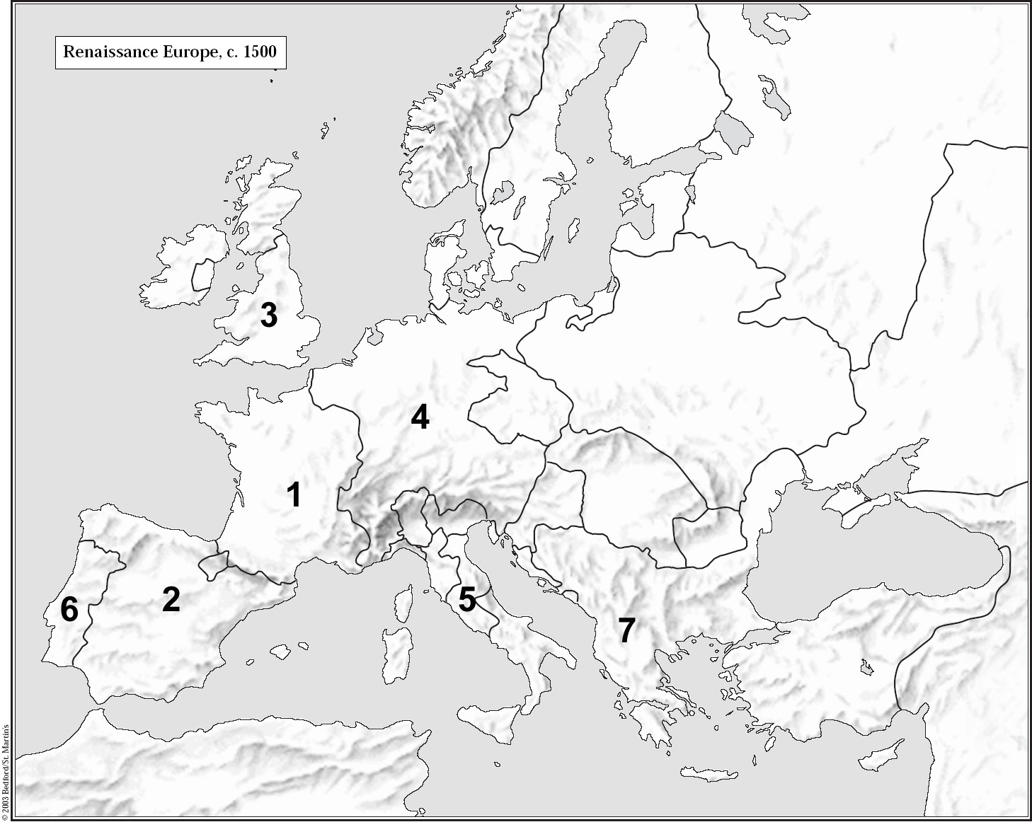

1. Name the polity______________________________

2. Name the polity______________________________

3. Name the polity______________________________

4. Name the polity______________________________

5. Name the region_____________________________

6. Name the polity______________________________

7. Name the polity______________________________

8. Label anything else of importance as #8, and name it here:

_____________________________________________

9. Label anything else of importance as #9, and name it here: _________________________________

10. Why did Mr. Crossen call # 5 a region and not a polity? __________________________________________________________________________________

__________________________________________________________________________________________________________________________________

11. Shade in the area of the Italian Renaissance, but shade in the Northern Renaissance darker.

