Period 3: 1754-1800
British imperial attempts to reassert control over its colonies and the colonial reaction to these attempts produced a new American republic, along with struggles over the new nation’s social, political, and economic identity.

Standard 3.1: Britain’s victory over France in the imperial struggle for North America led to new conflicts among the British government, the North American colonists, and American Indians, culminating in the creation of a new nation, the United States.

- Throughout the second half of the 18th century, various American Indian groups repeatedly evaluated and adjusted their alliances with Europeans, other tribes, and the new U.S. government. (ID-4) (POL-1) (ENV-2) (ENV-4) (CUL-1)

- English population growth and expansion into the interior disrupted existing French-Indian fur trade networks and caused various Indian nations to shift alliances among competing European powers.

- After the British defeat of the French, white-Indian conflicts continued to erupt as native groups sought both to continue trading with Europeans and to resist the encroachment of British colonists on traditional tribal lands.

  - Pontiac’s Rebellion
  - Proclamation of 1763

- During and after the colonial war for independence, various tribes attempted to forge advantageous political alliances with one another and with European powers to protect their interests, limit migration of white settlers, and maintain their tribal lands.

  - Iroquois Confederation
  - Chief Little Turtle and the Western Confederacy

- During and after the imperial struggles of the mid-18th century, new pressures began to unite the British colonies against perceived and real constraints on their economic activities and political rights, sparking a colonial independence movement and war with Britain. (ID-1) (WXT-1) (POL-1) (WOR-1) (CUL-2) (CUL-4)

- Great Britain’s massive debt from the Seven Years’ War resulted in renewed efforts to consolidate imperial control over North American markets, taxes, and political institutions—actions that were supported by some colonists but resisted by others.

  - Stamp Act
  - Declaratory Act
  - Committees of Correspondence
  - Intolerable Acts
  - Writs of Assistance

- The resulting independence movement was fueled by established colonial elites, as well as by grassroots movements that included newly mobilized laborers, artisans, and women, and rested on arguments over the rights of British subjects, the rights of the individual, and the ideas of the Enlightenment.

  - Sons of Liberty
  - Mercy Otis Warren
  - Letters from a Farmer in Pennsylvania

- Despite considerable loyalist opposition, as well as Great Britain’s apparently overwhelming military and financial advantages, the patriot cause succeeded because of the colonists’ greater familiarity with the land, their resilient military and political leadership, their ideological commitment, and their support from European allies.

- In response to domestic and international tensions, the new United States debated and formulated foreign policy initiatives and asserted an international presence. (WOR-5) (POL-2)

- The continued presence of European powers in North America challenged the United States to find ways to safeguard its borders, maintain neutral trading rights, and promote its economic interests.

- The French Revolution’s spread throughout Europe and beyond helped fuel Americans’ debate not only about the nature of the United States’ domestic order but also its proper role in the world.

- Although George Washington’s Farewell Address warned about the dangers of divisive political parties and permanent foreign alliances, European conflict and tensions with Britain and France fueled increasingly bitter partisan debates throughout the 1790s.

Standard 3.2: In the late 18th century, new experiments with democratic ideas and republican forms of government, as well as other new religious, economic, and cultural ideas challenged traditional imperial systems across the Atlantic World.

- During the 18th century, new ideas about politics and society led to debates about religion and governance and ultimately inspired experiments with new governmental structures. (ID-1) (POL-5) (WOR-2) (CUL-4)

- Protestant evangelical religious fervor strengthened many British colonists’ understandings of themselves as a chosen people blessed with liberty, while Enlightenment philosophers and ideas inspired many American political thinkers to emphasize individual talent over hereditary privilege.

  - John Locke
  - Jean-Jacques Rousseau
  - Adam Smith

- The colonists’ belief in the superiority of republican self-government based on the natural rights of the people found its clearest American expression in Thomas Paine’s Common Sense and in the Declaration of Independence.

- Many new state constitutions and the national Articles of Confederation, reflecting republican fears of both centralized power and excessive popular influence, placed power in the hands of the legislative branch and maintained property qualifications for voting and citizenship.

- After experiencing the limitations of the Articles of Confederation, American political leaders wrote a new Constitution based on the principles of federalism and separation of powers, crafted a Bill of Rights, and continued their debates about the proper balance between liberty and order. (WXT-6) (POL-5) (WOR-5)

- Difficulties over trade, finances, and interstate and foreign relations, as well as internal unrest, led to calls for significant revisions to the Articles of Confederation and a stronger central government.

  - Tariff and currency disputes
  - Shays’ Rebellion
  - Spanish restrictions on navigation of the Mississippi River

- Delegates from the states worked through a series of compromises to form a Constitution for a new national government while providing limits on federal power.

  - Great Compromise
  - 3/5 Compromise

- Calls during the ratification process for greater guarantees of rights resulted in the addition of a Bill of Rights shortly after the Constitution was adopted.

- As the first national administrations began to govern under the Constitution, continued debates about such issues as the relationship between the national government and the states, economic policy, and the conduct of foreign affairs led to the creation of political parties.

  - Kentucky and Virginia Resolutions
  - Hamilton’s Financial Plan
  - Proclamation of Neutrality
  - Federalist Party
  - Democratic-Republican Party

- While the new governments continued to limit rights to some groups, ideas promoting self-government and personal liberty reverberated around the world. (ID-4) (WOR-2) (POL-5) (CUL-2)

- During and after the American Revolution, an increased awareness of the inequalities in society motivated some individuals and groups to call for the abolition of slavery and greater political democracy in the new state and national governments.

  - Abigail Adams
  - Pennsylvania Gradual Emancipation Law

- The constitutional framers postponed a solution to the problems of slavery and the slave trade, setting the stage for recurring conflicts over these issues in later years.

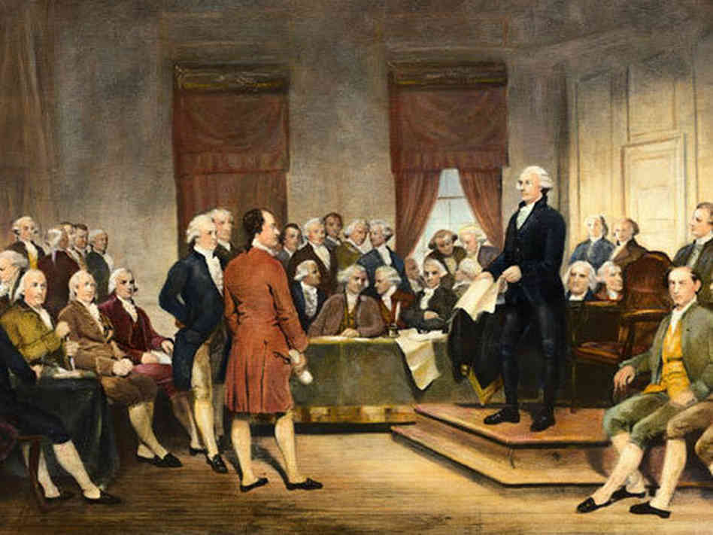
- The American Revolution and the ideals set forth in the Declaration had reverberations in France, Haiti, and Latin America, inspiring future rebellions.

Standard 3.3: Migration within North America, cooperative interaction, and competition for resources raised questions about boundaries and policies, intensified conflicts among peoples and nations, and led to contests over the creation of a multiethnic multiracial national identity.

- As migrants streamed westward from the British colonies along the Atlantic seaboard, interactions among different groups that would continue under an independent United States resulted in competition for resources, shifting alliances, and cultural blending. (ID-5) (ID-6) (PEO-5) (POL-1) (WOR-1) (WOR-5)

- The French withdrawal from North America and the subsequent attempt of various native groups to reassert their power over the interior of the continent resulted in new white-Indian conflicts along the western borders of British and, later, the U.S. colonial settlement and among settlers looking to assert more power in interior regions.

  - March of the Paxton Boys
  - Battle of Fallen Timbers

- Migrants from within North America and around the world continued to launch new settlements in the West, creating new distinctive backcountry cultures and fueling social and ethnic tensions.

  - Scots-Irish
  - Shay’s Rebellion
  - Frontier v. tidewater Virginia

- The Spanish, supported by the bonded labor of the local Indians, expanded their mission settlements into California, providing opportunities for social mobility among enterprising soldiers and settlers that led to new cultural blending.

  - Corridos
  - Architecture of Spanish missions
  - Vaqueros

- The policies of the United States that encouraged western migration and the orderly incorporation of new territories into the nation both extended republican institutions and intensified conflicts among American Indians and Europeans in the trans-Appalachian West. (POL-1) (PEO-4) (WOR-5)

- As settlers moved westward during the 1780s, Congress enacted the Northwest Ordinance for admitting new states and sought to promote public education, the protection of private property, and the restriction of slavery in the Northwest Territory.

- The Constitution’s failure to precisely define the relationship between American Indian tribes and the national government led to problems regarding treaties and Indian legal claims relating to the seizure of Indian lands.

- As western settlers sought free navigation of the Mississippi River, the United States forged diplomatic initiatives to manage the conflict with Spain and to deal with the continued British presence on the American continent.

  - Jay’s Treaty
  - Pinckney’s Treaty

- New voices for national identity challenged tendencies to cling to regional identities, contributing to the emergence of distinctly American cultural expressions. (ID-5) (WXT-2) (WXT-4) (POL-2) (CUL-2) (ENV-3)

- As national political institutions developed in the new United States, varying regionally based positions on economic, political, social, and foreign policy issues promoted the development of political parties.

- The expansion of slavery in the lower South and adjacent western lands, and its gradual disappearance elsewhere, began to create distinctive regional attitudes toward the institution.

- Enlightenment ideas and women’s experiences in the movement for independence promoted an ideal of “republican motherhood,” which called on white women to maintain and teach republican values within the family and granted women a new importance in American political culture.

